Planning for Comprehension



**intent:**

Practice planning for comprehension using the interaction and strategy ideas from the Preschool Curriculum Framework (PCF).

**OUTCOME:**

Participants use their personal knowledge in conjunction with information from the PowerPoint and the California Department of Education (CDE) resources to practice planning.

Dancing Clock

MCBS00539A0000[1]**Materials Required:**

* Short, developmentally appropriate book
* Handout 9: Planning for Comprehension

**Time:** 25 minutes

**Process:**

* 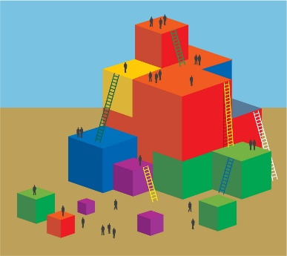Invite table groups to the back table to choose the book that they will use for planning.
* Guide participants to find Handout 9: Planning for Comprehension in their packet.
* Allow time for the participants to read their children’s book and to plan with their table group. Have them use the handout to guide their planning.
* Remind participants that they will have an opportunity to share-out at the end.
* Debrief:
  + Have each table group join another table group.
  + Allow time for each table group to share a summary of their plan with the group they joined.
  + Ask for highlights of the process:
    - What was easy? What was hard? What are you taking away from the experience? Do you like the planning form?

MCj02958800000[1]

**OPTIONS:**

* Have participants work in pairs instead of in table groups.
* Prior to the workshop, ask participants to bring their favorite children’s book with them to use for planning.