Cups Challenge | 
 | intent:  Participants work in groups to create a visual representation of the History-Social Science domain.

OUTCOMES:

Participants read the foundations chart, stack cups to represent the domain, and use string and rubber bands to problem solve how to move the cups without touching them.

 | Materials Required:  PPT slide  Partners/Tablemates  Preschool Learning Foundations (Volume 3)  13 Cups with labels:  1 cup for the Becoming a Community Member strand  1 cup for each of the following: democratic participation, fairness, responsible conduct, conflict resolution  4 cups for 48 months  4 cups for 60 months  Rubber bands  Six pieces of string  TIME: 15 minutes
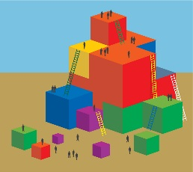 | Process:  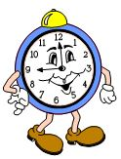  - Invite participants to turn to page 104 of the Preschool Learning Foundations (Volume 3) to find the foundation chart.  - Have groups send one member to gather their materials from the front (cups, string, rubber bands).  - Challenge participants to use the cups to represent the structure of the strand by building a pyramid. The challenge requires each group member to help move the cups without touching them.  - Ready, begin! Allow ample time for participants to experiment and laugh while building their pyramid; wait for all groups to be successful.  - Invite participants to answer the following questions:  - What skills did you use during this activity?  - Did you use any skills needed for children to build community?  - Did you have to make any decisions using the democratic process? If so, how did you do it?  - Did you have to consider fairness for the group? If so, how did you do it?  - Did all group members use responsible conduct? What happened when they didn’t? Or what would have happened if they didn’t?  - Did you have to resolve any conflicts? If so, how did you do it?

