Various Ways to Wrap a Baby | 
 | intent:  Allow participants to share their personal experiences and learn from one another.

OUTCOMES:

Participants will share insights and learn from one another as they teach each other how they typically wrap and hold a baby.
 | Materials Required:  PPT slide  Partners    One baby-doll per table group  A few different sizes and types of blankets per group  TIME: 10 minutes
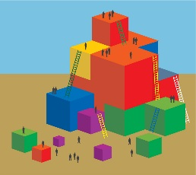 | Process:  - Share the PPT slide that highlights the importance of teachers to both acknowledge and have a healthy curiosity for diversity in the classroom—and in life.  - Welcome participants again. Tell them that we will model this type of curiosity today by having an open mind while listening to and learning from everyone; we will start by sharing a little bit about our own personal knowledge and cultural practices in a fun way.  - Use one of the baby dolls to model how you typically wrap a baby and share your method with the entire group. Now say, “We want to learn about other ways to wrap a baby and to see all the diversity we have in the room.”  - Guide participants to find the baby dolls and different wrapping options on the tabletops.  - Provide 10 minutes for participants to take turns sharing, demonstrating, and even teaching how they typically wrap a baby (each member should take a turn).  - Walk around during this time and take photos to use for the slide show at the end of the day.  - Make note of the variety of methods to point out at the end of the activity.  - Invite anyone who learned a new way to wrap a baby—and wishes to share—to come forward and demonstrate for the entire group.  - Option: Share the unique variety of ways to wrap a baby you observed and took notes on during the activity.  - Wrap-up by saying, “It is clear that we have a vast wealth of knowledge in the room and a diverse set of experiences. We will glean more from our knowledge and experiences as we learn and share from one another throughout the day. We will also return to this baby-wrapping experience later in the day when we touch on anti-bias curriculum.”

