Community Brainstorm | 
 | intent:  Participants brainstorm for a variety of communities children may be a part of.

OUTCOMES:

Participants discuss potential communities children may be a part of.

 | Materials Required:  PPT slide  Preschool Learning Foundations (Volume 3)  Partners/Tablemates  Chart paper  Markers  TIME: 10 minutes
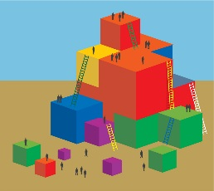 | Process:  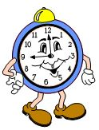  - Invite participants to again turn to page 104 of the Preschool Learning Foundations (Volume 3) to find the foundation chart.  - Have groups send one member to get the chart paper for their group.  - Ask one participant from each group to volunteer as a recorder.  - Have groups brainstorm for all the potential communities that their students might be—or might have been—a part of. The recorder will create a list of all the ideas produced during the brainstorming session.  - Wait until all groups have a long list of communities, then pose the following questions: What knowledge do you have of this community? Do you know the social norms? Have you been a part of a similar community in the past?  - Potential Answers: Church, neighborhood, children from the same apartment complex, library groups, youth groups, family, family childcare, afterschool care, children from the same preschool, etc.  - Debrief: The connections that students already have are what their existing knowledge of communities is based upon. To be as effective as possible in building a TK community we must build on this existing knowledge.

