Match ‘Em Up: Movement and Memory | 
 | intent:  Participants review key terminology.

OUTCOME:

Participants will match up vocabulary cards.

 | Materials Required:  PowerPoint slide  Preschool Learning Foundations, Volume 3  Handout 3: Glossary  Vocabulary cards  TIME: 10 minutes
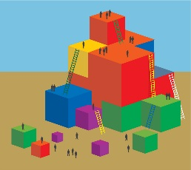 | Process:  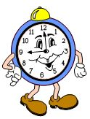  Part 1  - Have participants find the glossary in the Preschool Learning Foundations for reference. This glossary is specific to the strands in the History-Social Science (HSS) domain.  - Remind participants that although we are focusing on the Sense of Time and Sense of Place strands today, all the HSS strands are interrelated. Also, as learning is integrated, many other domains are supported when we support HSS.  - Share that in order to best support children’s learning environments, we need to have the deepest understanding possible of the vocabulary in the History-Social Science domain.  - Ask participants to glance through the glossary to become familiar with the terms.  Part 2  - Point out the cards table and ask that they be distributed face down for the game “Match ‘em Up”—a movement form of the childhood card game, “Memory.”  - Tell participants, “When I say ‘go,’ navigate your way through the cards and try and get as many matches as you can. Ready…go find matches!”  - After about one minute say, “Now tip-toe to find the matches.”  - After another minute say, “Duck walk to find matches.”  - Repeat with several movements (slides, jumps, hops, backwards walking, squat walking, etc.).  Debrief:  - This game highlights how movement can be incorporated into the strategy.  - How might you use a similar game in class?  - How might you incorporate the vocabulary into daily interactions, either through teacher knowledge or actually use of the vocabulary?

