Video Observation | 
 | intent:  Create a mental representation of what various aspects highlighted in the Preschool Curriculum Framework might look like in the classroom.

OUTCOMES:

Participants will take detailed notes on a video and connect the video to various aspects and sections of the Preschool Curriculum Framework.

 | Materials Required:  Substrands and Foundations Chart PPT slide  Partners  - Exchange video  - Handout 4: Video Observation Guide  TIME: 15 minutes
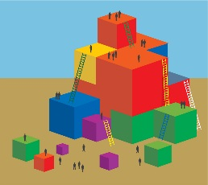 | Process:  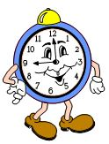  Part 1  - Ask participants to take out Handout 4: Video Observation Guide.  - Explain that the whole group will watch a short video clip; each participant will be responsible for filling out the observation guide following the video.  Show the video.  Allow five minutes for participants to fill out Handout 4: Video Observation Guide.  - Ask participants to find a partner from a different table group. Have partners discuss and reflect upon the video and the observation guide.  - Walk around and listen to the different conversations; jot down conversation highlights.  - Bring the group back together:  - Share the partner conversation highlights.  - Ask if there are any partners that want to add to or confirm the conversation highlights.  - Ask participants to share any “ahas” or interesting “take-away” ideas from this activity.  Part 2  - Go to the Substrands and Foundations Chart PowerPoint slide.  - Have participants stand up if they observed evidence of any of the following substrands in the video (participants could potentially stand for each bullet point):  - Self and Society  - Becoming a Preschool Community Member  - Sense of Time  - Sense of Place  - Marketplace  - Debrief:  - Say, “History-Social Science is integrated, not only within the domain, but with other domains as well. Let’s do a ‘popcorn’ of other domains or strands of learning that were evidenced in the video. Ready, go!”  - Wait for participants to start calling things out. Another trainer may chart this as they go.  - Say, “Excellent! As we continue today we are going to focus on two strands of History-Social Science that are closely related—Self and Society and Marketplace. However, we want to also remember the overall integration of the domain; please try to keep this in mind with everything we do today.”

