Read a Little, Reflect a Little | 
 | intent:  Participants look at pictures and discuss the ways environments and materials can be used in support of the History-Social Science (HSS) Sense of Time and Sense of Place domains.

OUTCOMES:
Participants will view photo slides, discuss ways the environments and materials in the photo can be used to support the HSS Sense of Time and Sense of Place domains, and chart responses to the following questions in relation to each photo:
- How does it support English learners?
- How does it support the Sense of Time substrand?
- How does it support the Sense of place substrand?
- What adaptations might you consider to this scene to meet the specific needs of your classroom?

 | Materials Required:  Preschool Learning Foundations (PLF), Volume 3, pp. 15-21  Table group letters (A-F)  PowerPoint slides  Chart paper  Markers  TIME: 15 minutes
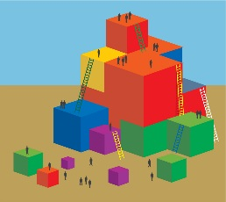 | Process:  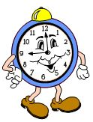  - Prior to the training, hang chart paper around the room.  - Ask table groups to identify their table letter (A-F).  - Have participants look at the slide to determine their assigned section in the Preschool Learning Foundations introduction (based on table letter).  - Give participants five minutes to read their identified section of the Preschool Learning Foundations introduction.  - Remind participants that each of them is responsible for being the resident expert for their assigned section, so they should take notes.  - When participants are done reading, invite each table group to stand and split up so that one person from each table group is standing by each piece of chart paper.  - Adaptations will need to be made with very large groups to account for additional people.  - Go through the six photo slides one at a time, pausing after each to allow participants to study the slide, discuss it with their group, and chart responses to the following questions in relation to each photo:  - How does it support English learners?  - How does it support the Sense of Time substrand?  - How does it support the Sense of place substrand?  - What adaptations might you consider to this scene to meet the specific needs of your classroom?  - Walk around the room as the groups discuss their ideas. Listen for key examples that can be highlighted.  Debrief:  Highlight some of the key examples that were discussed. Next, invite participants to go back to their table groups and to do a debrief of all the ideas for environments and materials that they want to remember from these photos and discussions.

