PRoPELS Strategy | 
 | intent:  Apply the PRoPELS strategy and anti-bias approach toward the creation of a new dramatic play strategy that supports social roles and marketplace concepts.

OUTCOMES:

Participants will study the PRoPELS strategy, watch a video example, think through the PRoPELS strategy by answering and charting reflective questions with their table group, and begin making props for their new dramatic play area.

 | Materials Required:  - PPT slide  - Handout 11: PRoPELS Strategy  - Table groups  - Materials for dramatic play props: Paints, markers, boxes, tape, construction paper, feathers, flowers, newspaper, recycled materials, yogurt containers, egg cartons, etc.    TIME: 20 minutes
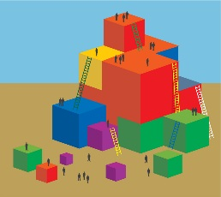 | Process:  - Ask participants to locate Handout 11: PRoPELS Strategy.  - Have participants brainstorm dramatic play scenarios they think their students would be interested in.  - Ask groups to work through the reflective questions on Handout 11: PRoPELS Strategy. They should chart their responses in a way that can be shared with the entire group.  - Direct groups to use the open-ended materials to begin creating their dramatic play physical environment; these props will be shared with the entire group as well.  - Allow time for groups to finish creating their dramatic play environments.  - Have participants take a gallery walk to view the various charts and dramatic play environments.

