Community Art | 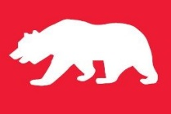
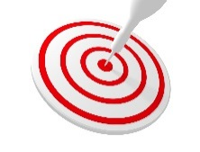 | intent:  Participants create a community art experience.

OUTCOMES:

Participants use materials to create an art experience that requires peer interaction.

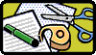 | Materials Required:  PPT slide  Community Art video (https://cpin.us/sites/default/files/CC/PD/Community%20Art%20Video.MOV)  Partners/Tablemates  Art materials:  Large canvas, butcher paper, balls, paints, yarn, swimming pool noodles, straws, poof balls, chalk, balloons, blocks, cars, bubble wrap, etc.  TIME: 25 minutes
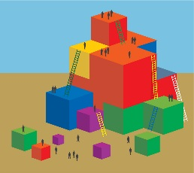 | Process:  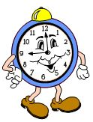  - Invite participants to select some art materials to work with; they can go back and get more at any time.  - Show the Community Art video, then task participants with creating a fun way of doing art together.  - Remind participants that the art experience they create should include all members of the community working together—not just “side-by-side” art.  - Have participants first brainstorm individually to come up with ideas, then have them join up in teams to create an art experience. (Allow ample time for groups to finish.)  - Ask teams to remain together as you lead the entire group through the following reflective questions; record their responses on chart paper:  - What problems did you think through while coming up with this idea?  - What solutions did you come to?  - In your class, which children would this specifically benefit?  - How might you scaffold this activity?  - If you were to take anecdotal notes for this activity, what other domains would you expect to see?

