Final Vignette | 
 | intent:  Participants read a vignette and apply information therein to help plan a mapping experience.

OUTCOME:

Participants plan a mapping experience for their classroom and draw connections between the DRDP-K (2015) measures and the foundations.

 | 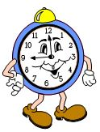  Materials Required:  PowerPoint slide  Preschool Curriculum Framework, Volume 3, p. 115  Butcher paper  Markers  Other materials  TIME: 20 minutes
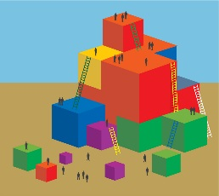 | Process:  Ask participants to read the vignette on page 115 of the Preschool Curriculum Framework, Volume 3.  - Have participants chart their responses to the following questions as they read:  - What evidence is there that Mr. Kyle is considering a sense of time?  - How do you know he is grounding the activity in what's meaningful for children?  - How does he include all students?  - Ask participants to think of their children. What event of the children’s interest can they connect to?  - Give the participants the following directions:  - Using the vignette as a model, create a similar map experience that also considers time.  - Use the butcher paper to pre-draw a map of your program to use in your activity.  - You may use any materials.  - Ask participants:  - Which foundations in the History–Social Science domain did you consider while planning this experience?  - Use the PowerPoint slide for review.  - What DRDP-K (2015) measure might you collect evidence for during this experience?  - Use the chart for review.

