- Autobiographical memory  Memory of personal events in one’s life. | 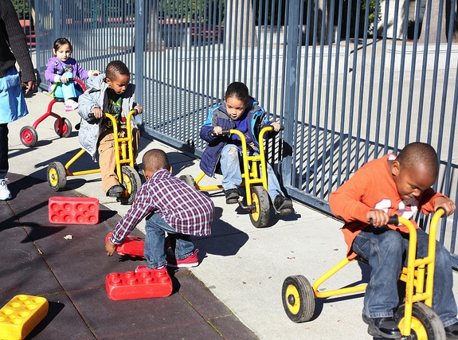
- Bartering
Trading by exchanging things of value rather than money.
- Civics
Study of the privileges and obligations of citizens.
- Consumer
A person who uses (and thus may purchase) something of value, such as an object or a service.
- Ecology
The field of biology concerned with the relationship between organisms (including humans) and the environment
- Economic change
Giving one thing of value for another thing of value, such as giving money to a shopkeeper to purchase food.
- In-group bias
The tendency of people to prefer the characteristics of their own group. In young children, this does not necessarily mean that they are negative toward other groups.
- Intuitive
Understanding something by natural reasoning rather than by learning from another.
- Mental “scripts”
Understanding of how things happen in familiar routines, such as what occurs when going to a restaurant, getting ready for bed, and so on.

- Moral standards
Expectations for behavior that are based on the needs and welfare of people, such as not harming another; they tend to be consistent in different situations.

Activities shared between people (such as a parent and child) involving the use of language to create a story or account, such as talking about a shared experience, storytelling, or reading a book.

- Natural phenomena
Things that can be observed in the natural world, such as plants and animals, the stars, sun and moon, insects, and other objects and events.
- Pro-social
Positive and cooperative; sharing with another child is an example of pro-social behavior.
- Scale
The proportional relationship of a unit on one area (such as a map) and how it corresponds to a unit in the real world that it represents. A map scale is necessary for reading a map because one must understand how distances on the map correspond to distances in the region that the map represents.
- Social conventions
Expectations for behavior that are based on maintaining social order, such as sitting in the right place for circle time; they may differ depending on the context.
- Time line
The linear sequence of events in time. Children understand, for example, that grandparents were born before parents were, or that George Washington lived before Abraham Lincoln.

