Making Connections | 
 | intent:  Allow participants to explore the introduction and to compare language use and conventions skills with grammar skills through a jigsaw reading and graphic representation.

OUTCOMES:

Participants will read about, organize, and share information regarding language use and conventions and grammar skills.

 | Materials Required:  PPT slide  Table groups  Chart paper  Preschool Learning Foundations (Volume 1)—introduction section  Trainer Tool: Language Use and Conventions and Grammar Work Together Cut-Outs (printed, cut out, and placed in envelopes labeled “Skill Circles”)  Tape for each table group  TIME: 15 minutes
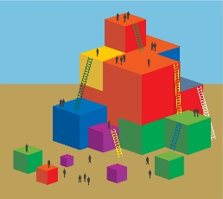 | Process:  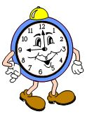  - Ask groups to jigsaw-read the relevant introduction sections of the Preschool Learning Foundations (Volume 1):  - Language Use and Conventions (pp. 49-50)  - Grammar (pp. 51-52)  - Ask groups to locate the envelope labeled “Skill Circles” on their tabletop.  - Direct groups to use the skill circles and chart paper to create a visual graphic representing/organizing what they read.  - Advance the slide and share the sample representation (Language use and conventions skills are shown in red; grammar skills are shown in green.).  - Invite table groups to share their graphics.  - Highlight the integrated nature of these two substrands and the connection between skills.

