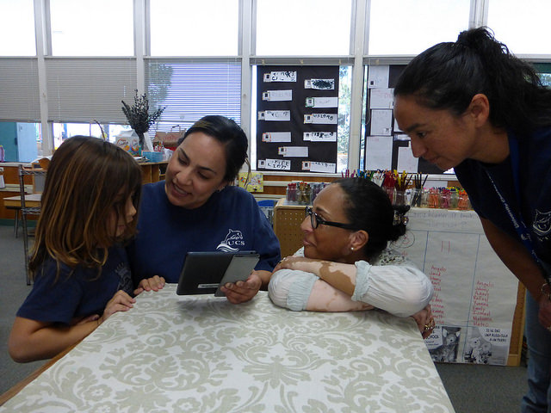

* **Invite children to engage and respond in any language.**
* **Accept code-switching as normal.**
* **Initiate conversation about topics that are in the here and now.**
* **Invite children to engage and respond using an alternate communication device.**
* **Use visual strategies to support communication.**
* **Collaborate with a special education provider to learn about the alternate communication systems of individual students.**

**Alternate Communication**

**System Considerations**

* **Small group time: Tables, carpet, outside small group time, etc.**

* **Free choice time/Work time: Block area, dramatic play area, library, math centers, sensory tables, writing center, etc.**
* **Outside time: Sand box, dramatic play time, nature exploration, etc.**
* **Arrival/Dismissal**
* **Snack time**

**What is strive for five?**

**Strive for five refers to a conversational exchange that lasts for five or more turns—back and forth—between a teacher and child.**

* **Be stationary long enough to converse**
* **Make eye contact on the student’s level**
* **Ask honest (open‐ended) questions**
* **Genuinely seek understanding**
* **Expand and extend children’s comments**
* **Contribute ideas, experiences, and knowledge without taking over**

**When and where can teachers strive for five?**

**Home Language Considerations**

**How can a teacher strive for five?**

©2017 California Department of Education