Cross Word Puzzle





**intent:**

Explore the vocabulary used in the phonological awareness foundations by completing a crossword puzzle.

**OUTCOME:**

Participants explore the terminology used in the introduction and the glossary sections of the Language and Literacy Development domain.



**Materials Required:**

* 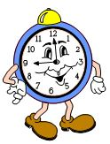Preschool Learning Foundations (Volume 1) language and literacy foundations introduction and glossary
* Crossword Puzzle handout
* OPTIONAL—Answer key handout for Crossword Puzzle

**Time:** 10-15 minutes

**Process:**

* 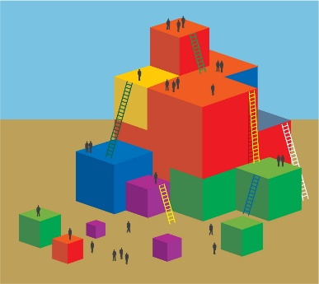Ask participants to find a partner at their table. Together, partners should complete the crossword puzzle. Participants may use the glossary (p. 89) and the introduction (pp. 52-53) in the Preschool Learning Foundations (Volume 1) for assistance as necessary.
* When the allotted time has elapsed, review the puzzle aloud while showing the PowerPoint slide. Based on the group’s level of knowledge, either provide examples or ask volunteers to provide examples of the various terms. Encourage participants to record the various examples on the crossword puzzle handout.

**OPTIONS:**

Provide an answer key to each table or to participants individually.

**REFLECTION:**

Emphasize that children do not consistently master phonological awareness less than four years of age AND that vocabulary development may facilitate the development of phonological awareness.