Time to Play Language Games


intent:
Gain experience playing a language game that connects with phonological awareness concepts.

OUTCOMES:
Participants will practice leading a language game. They will discuss specific prompts to scaffold the language game for the children in their programs.

Materials Required:

- One bag per table containing one of three activity lesson plans, plus game materials listed on less plans
- Handout 10: Time to Play Games

Time: 20 minutes

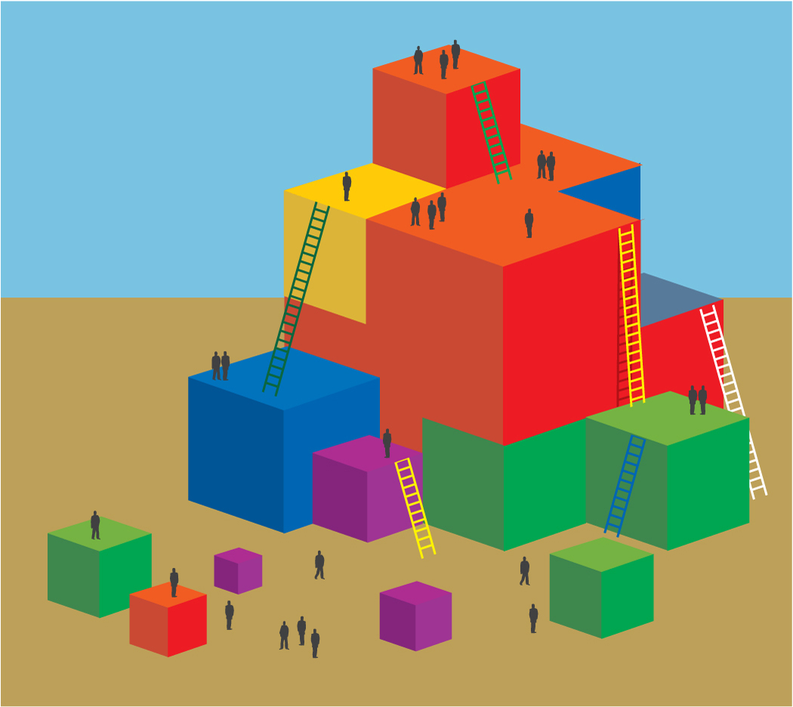
Process:
- Each table has a bag of supplies for one of the three games in Handout 10: Time to Play Games.
- Invite each table group to stand up when the name of their game is called. “Stand if your group has Wiggly Wordy Wallaby’s. Stand if your group has Ghostly Language. Stand if your group has Roll-a-Word.”
- Have participants spend 5 minutes reading the lesson plan and playing the game with their group.
- Invite participants to think about their specific activity, and brainstorm how the teacher would lead the activity or prompt children to scaffold the specific phonological awareness content being addressed.
- Participants can use the activity handout as a guide to help facilitate their thought process.
- Invite table groups to share out their game, as well as one thing they learned or thought of during the process.

OPTIONS:
- Break up into three large groups and only have one group per lesson plan. Have one presenter model the activity in each group and facilitate the discussion.
- Choose only one game to use and have everyone work with the same lesson plan to make facilitating conversation and share out time smoother and more consistent. This may be a good strategy for working with a wide variety of teaching levels.
REFLECTION:
- Once participants begin to play the game and think about scaffolding, they will reflect on how they typically guide classroom activities.
- Participants can integrate this new game, and their knowledge of scaffolding, into their daily routine.

