Roll-A-Word

Get Ready:
- Space:
  - Indoors or outdoors
  - At a table or an open space such as a carpet
- Materials:
  - 2 dice with picture of objects on each face (glued or fastened with Velcro)
    - See list of example objects

Get Set:
- Children will roll the dice and put the names of the objects in the pictures together to make a compound word.
- Adult will facilitate conversations around blending and segmenting compound words.

Go:
Two children are chosen to start the game. Each child is given one die. Teacher directs the children to roll their die. Teacher guides children to push the showing faces of the dice together.

The teacher says something similar to, “You have word, and you have word. Together you have compound word. Is that a silly word or a real word? Yup, you’re right! It’s a (silly or real) word and it’s a compound word because it’s two words together”.

Example objects:
- Rain
- Bow
- Shoe
- Fly
- Butter
- Fire
- Truck
- Ice
- Cream
- Sun
- Glasses
- Heart
- Lace
Wiggly Wordy Wallabies
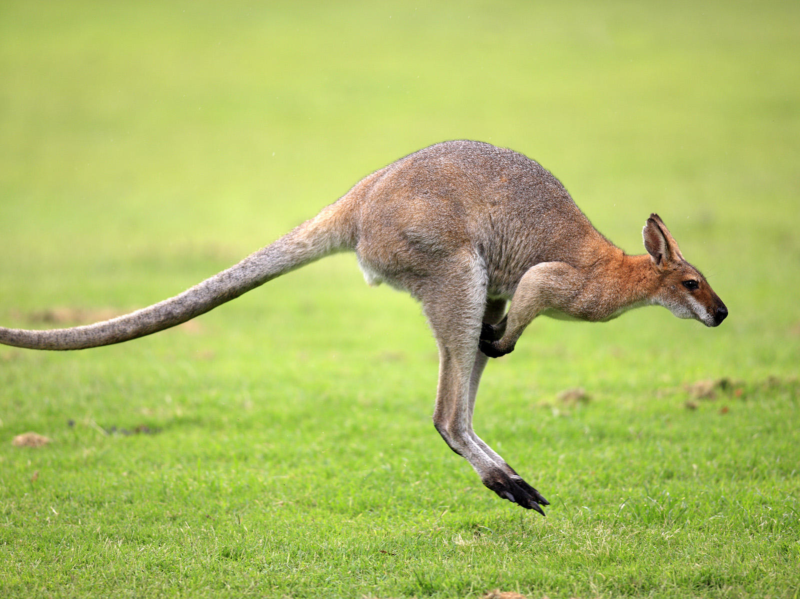

Get Ready:
- Space:
  - Indoors or outdoors
  - An open space such as a carpet
- Materials:
  - Laminated sequence of squares for each player
  - Objects or pictures of objects for teacher
  - Fanny pack, apron, or front pocket to act as a wallaby pouch for teacher

Get Set:
- The teacher will choose an object.
- Children will jump each syllable, moving forward on their sequence of squares.

Go:
The teacher will explain, “Wallabies are similar to kangaroos because they jump and they have a pouch. Look I have a pouch just like a wallaby. Wiggly word wallabies are special and they jump for certain parts of words. Today, wiggly word wallabies are going to jump for syllables. I will show you an object from my pouch, and together all of us wiggly word wallabies will jump out the syllables in the word. We will each jump along our own path.”

The teacher will model the first object, “Look, I have a ba-na-na in my pouch! Are we ready wiggly word wallabies? Let’s jump out ba-na-na. Alright, we all moved forward!”

The teacher will repeat several times.

Example objects: Banana, strawberry, bracelet, butterfly

Ghostly Language

Get Ready:
- Space:
  - Indoors or outdoors
  - An open space such as a carpet
- Materials:
  - Ghost masks
  - Objects or pictures of objects for teacher
  - Beginning-Middle-End chart

Get Set:
- The teacher will choose an object.
- Children will practice talking like a ghost, saying the name of the object slowly so that they can delete the onset or rime.

Go:
The teacher introduces the ghostly game by talking like a ghost, “We are going to pretend to be ghosts and talk slowly. Then, I will try and trick you by leaving out a sound to see if you can still understand my ghostly language”.

The teacher models the first object, “I have a star. Use your ghostly language to say star with me; ‘star’. Now what if I say star with no ‘s’ sound. What would I say?”

The teacher waits and repeats as necessary.

The teacher repeats these steps with other objects.

Note: This game can focus on onset and rime or phonemes.

Example objects: Banana, ball, ring, cup.

