Relations-Style Simon Says


intent:
Participants explore strategies for vocabulary development through word games.

OUTCOMES:
Participants will do the following:
- Play a game of relations-style Simon Says.
- Discuss other word games that could be used for vocabulary building.

- Design one game for building children’s vocabulary.

Materials Required:
- Handout 6: Language Game Lesson Plan Ideas

TIME: 30 minutes

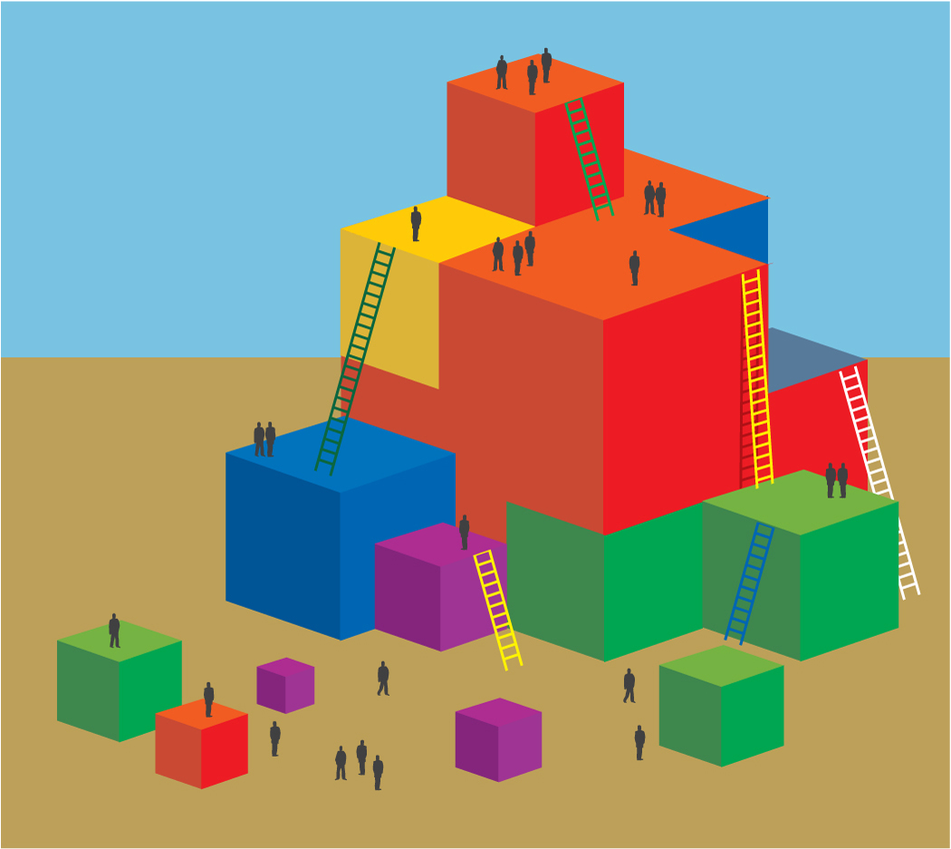
PROCESS:
Part 1: With the whole group
- Ask participants to stand up to play relations-style Simons Says. This is an adaptation to the original game that focuses on relation-based vocabulary (foundation 2.3).
- Play Simon Says focusing on using preposition or relationship words. For example:
- Simon says—place your hands behind your back.
- Simon says—place your nose under your arm.
- Simon says—put your finger on something bigger than your arm.
- Clap your hands three times. Uh oh, did some of you think you heard Simon says?
- Let’s pause the game. Look around ask a friend if they heard Simon says. (Let participants self-correct with guidance, modeling how to play with children so there are no children who are “out.”)
- Let’s start the game again, listen for me to say Simon says first.
- Simon says—…

Part 2: Within table groups
- Have table groups brain storm potential word games:
o Decide on one game to modify.
o Adapt the game to focus on relation-based vocabulary.
o Partner with another table and teach each other your games.
• Give participants the option to write the game ideas down on Handout 6:
Language Game Lesson Plan Ideas.
- Ask the following questions:
o What are word games that you currently play in the classroom?
o How could you change those games to focus on relation-based vocabulary?

