
Which Substrand Am I?

intent:
Give participants an opportunity to become familiar with the physical development framework.

OUTCOME:
Participants will look at the physical development handouts copied from the Preschool Learning Foundations and Preschool Curriculum Framework to identify which physical development substrand matches the correct pictures.


Materials Required:
- One per participant – Handout 2: Physical Development Domain Alignment and Handout 5: PCF PD Chapter (pages 131-138)
- One per table - Physical Development Strand Activity Cards (envelope with laminated nine substrand cards)
- One per table – Photo Envelope with nine photos that illustrate the nine substrands (see picture of photos below)

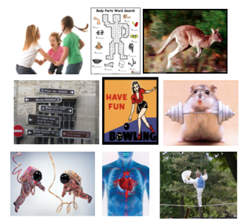

Time: 10 min.

Process:
- Prior to activity, place Physical Development Strand Activity Cards and Photo Envelope on each table.
- Participants work cooperatively as a table to research and match each substrand card to a photo using Handout 2: Physical Development Domain Alignment and Handout 5: PCF PD Chapter (pages 131-138).
- Facilitators move around the room to support participants and listen to conversations.
- Share out results by holding up one picture and asking for answer from the group. If a table has a different answer, ask if someone is willing to share their rationale. It is okay if there are different interpretations. If someone has a different viewpoint, it is important that participants feel safe to share.

OPTIONS:
- Use photos of children engaged in physical activities instead of the ones provided for this activity.
- Show video clips and ask people to identify the strand by holding up the foundation substrand card.
- Have facilitator act out a substrand and participants hold up the foundations substrand card that matches the action.
- Facilitator can hold up a substrand card, or project the substrand name on the screen, and ask the group to stand and demonstrate it.
- If not laminated, materials may be printed on cardstock.

