
Brain Break with Rags

intent:
Provide a brain break for participants that involve physical activity.

OUTCOME:
Participants will engage in a simple tossing activity to increase blood flow to the brain and realize how the brain and muscles work effortlessly together.


Materials Required:
- Music player and upbeat song (trainer’s choice)

- Four rags for each table (washcloth, dinner napkin, or car wash rags that can be purchased from a large retail or auto parts store)

Time: 3-4 min.

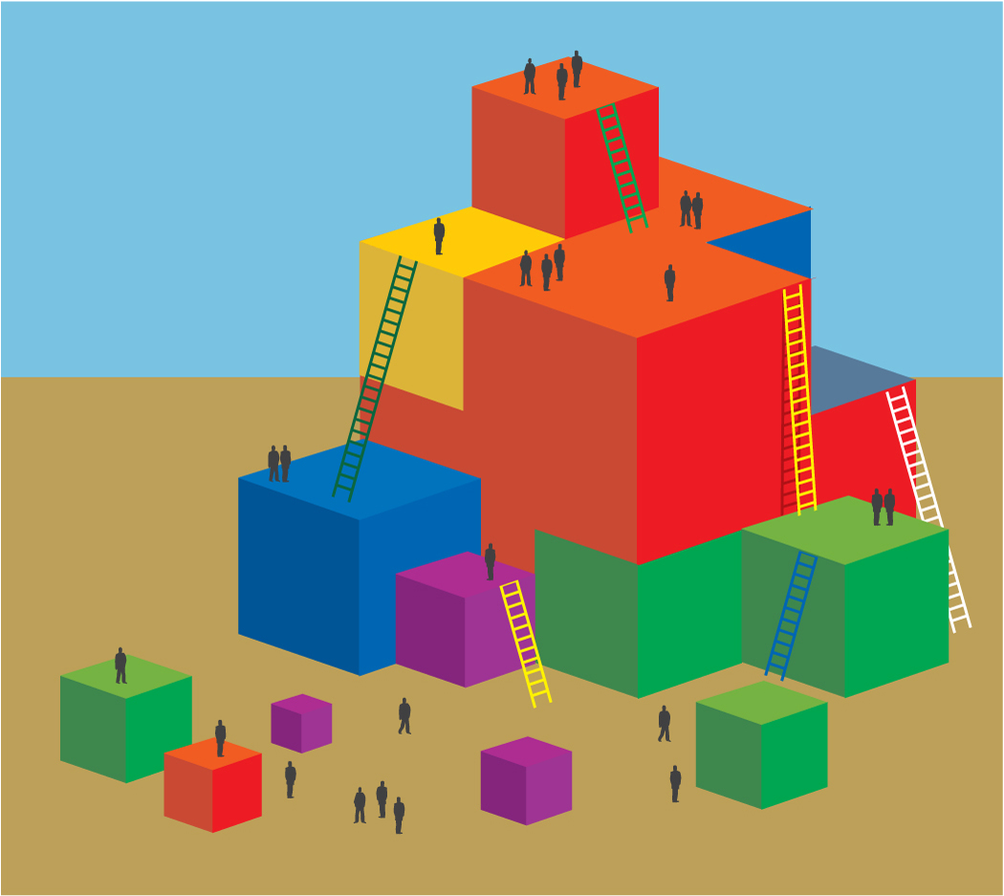
Process:
- Prior to activity, place four rags on each table.
- Invite all participants to stand behind their chair for the brain break activity. Check clothing and shoes and push in chairs at tables, along with bags/totes/etc. Check area for possible safety hazards.
- Introduce the activity and direct each table to gently toss one rag around the table. Begin music.
- After 20 seconds, add an additional rag so each table is tossing two rags simultaneously. Toss for about 30 seconds. Add the additional rag every 20-30 seconds stopping music each time.
- After the activity, ask questions to illustrate how integrated the brain and muscles are when they are doing a physical task: What was easier to toss and catch - one towel or multiple towels? What did your brain have to do to keep all the rags going? Did you consciously change the way you were tossing and catching the rags when there were multiple rags?
- After the song ends, have the group take a deep breath and then sit down.

OPTIONS:
- This activity illustrates how physical activity does not have to be expensive. Items found around the house can be recycled into play props.
- Share this activity with families to illustrate how easy it is to engage brain and muscles together in physical activity.

