 We Count with Numbers



**intent:**

Engage participants in a song that integrates movement, math,   
and sign language across the curriculum.

**OUTCOMES:**

* Participants will actively engage to prompts in the song integrating math, movement, and sign language illustrating how physical activity can be blended with content areas.
* MCBS00539A0000[1]Participants will learn how to sign numbers from 1-10 in American Sign Language increasing their cultural awareness and sensitivity to children with special needs.

**Materials Required:**

* Song: *We Count with Numbers*, by Angela Russ, CD: Math, Music & Motion ([www.ABridgleClub.com](http://www.ABridgleClub.com))
* Music player
* PowerPoint slide with prompts for movement
* Space around tables for each participant to move safely

**Time:** 4 minutes

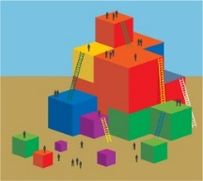**Process:**

1. Invite all participants to stand behind their chair for the song. Check clothing and shoes and push in chairs at tables, along with bags/totes/etc. Check area for possible safety hazards.
2. Introduce and practice the hand signs (American Sign Language) for numbers 1-10. Use the PowerPoint slide as a visual aid.
3. Explain how the song has movements for each number (shown on PPT slides), do the movements for the number one as practice. At the end of each verse, count from the number one all the way up to the new number.
4. Begin the song. Advance the slides for the movement activities for each number. See hand signs for each number, lyrics and movements on the next page.

**OPTIONS:**

* Song prompts are suggestions. Change/modify as desired.
* Instead of doing both movements, only move to the first prompt.
* Signs are taught to adults to challenge them, but children can just show fingers for counting part.

**American Sign Language Number Signs, 1-10**

Visit American Sign Language Professional, [www.aslpro.com](http://www.aslpro.com), for a free online video dictionary of over 7,200 ASL Signs

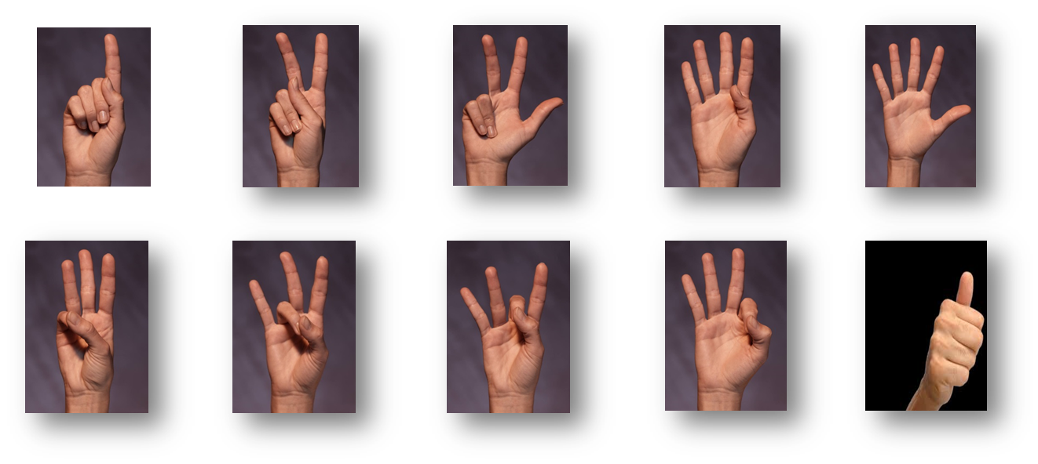

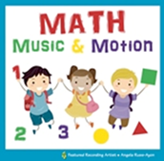

**We Count with Numbers**

**CD: Math, Music & Motion by Angela Russ**

|  |  |
| --- | --- |
| **Lyrics** | **Movements** |
| Can you show me the **number 1?**  1 big rainbow  1 squat down low  1  Can you show me the **number 2?**  2 pats on your chin  2 jumps on in  1,2  Can you show me the **number 3?**  3 waves in the air  3 stomps like a bear  1,2,3  Can you show me the **number 4?**  4 knocks on the door  4 steps on the floor  1,2,3,4  Can you show me the **number 5?**  5 ins and outs  5 hops all about  1,2,3,4,5  Can you show me the **number 6?**  6 claps to the beat  6 kicks with our feet  1,2,3,4,5,6  Can you show me the **number 7?**  7 taps on your knee  7 climbs up a tree  1,2,3,4,5,6,7  Can you show me the **number 8?**  8 ups and downs  8 marches around  1,2,3,4,5,6,7,8  Can you show me the **number 9?**  9 flaps on the sides  9 slides and glides  1,2,3,4,5,6,7,8,9  Can you show me the **number 10?**  10 circles with your wrist  10 turns and twists  1,2,3,4,5,6,7,8,9,10 | *Sign the number 1*  *Arms sweep in arc overhead*  *Squat down low one time*  *Sign number 1*  *Sign the number 2*  *Pat your chin two times*  *Jump two times*  *Sign numbers 1, 2*  *Sign the number 3*  *Wave three times*  *Make three loud stomps with feet*  *Sign numbers 1, 2, 3*  *Sign the number 4*  *Knock in the air four times*  *Step in place until counting begins*  *Sign numbers 1, 2, 3, 4*  *Continue on next page…*  *Sign the number 5*  *Raise elbows to the side, then down by side, repeat*  *Hop on one foot until counting begins*  *Sign numbers 1, 2, 3, 4, 5*  *Sign the number 6*  *Clap to the beat*  *Do a kicking action until counting begins*  *Sign numbers 1, 2, 3, 4, 5, 6*  *Sign the number 7*  *Tap your knees with your hands*  *Do a kicking action until counting begins*  *Sign numbers 1, 2, 3, 4, 5, 6, 7*  *Sign the number 8*  *Squat up and down*  *Marching until counting begins*  *Sign numbers 1, 2, 3, 4, 5, 6, 7, 8*  *Sign the number 9*  *Flap elbows or arms like a bird*  *Slide feet on the floor, like skating, until counting begins*  *Sign numbers 1, 2, 3, 4, 5, 6, 7, 8, 9*  *Sign the number 10*  *Turn wrist in circles*  *Twist and turn in place until counting begins*  *Sign numbers 1, 2, 3, 4, 5, 6, 7, 8, 9, 10* |