HOW TO MAKE A YARN ROPE
By Patty Kimbrell, M.Ed.

Supplies:
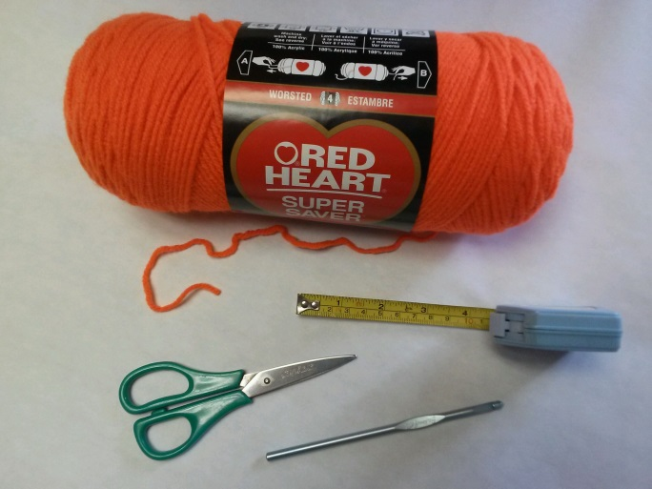

-Yarn (colors of the rainbow are preferred)
-Crochet needle – Size 8 or H or similar
-Scissors
-Measuring tape
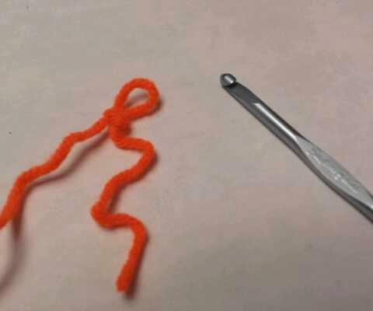
Directions:

- With crochet needle and yarn, make a small slip knot in the yarn to begin the yarn rope.

- Hold yarn in one hand, the crochet needle in the preferred hand. To crochet a single chain, place the crochet needle behind the yarn, then pull the yarn through the loop with the crochet needle. Repeat until desired length of rope is achieved. Yarn ropes may be made in a variety of lengths; for young children, a 3-4’ rope is recommended.
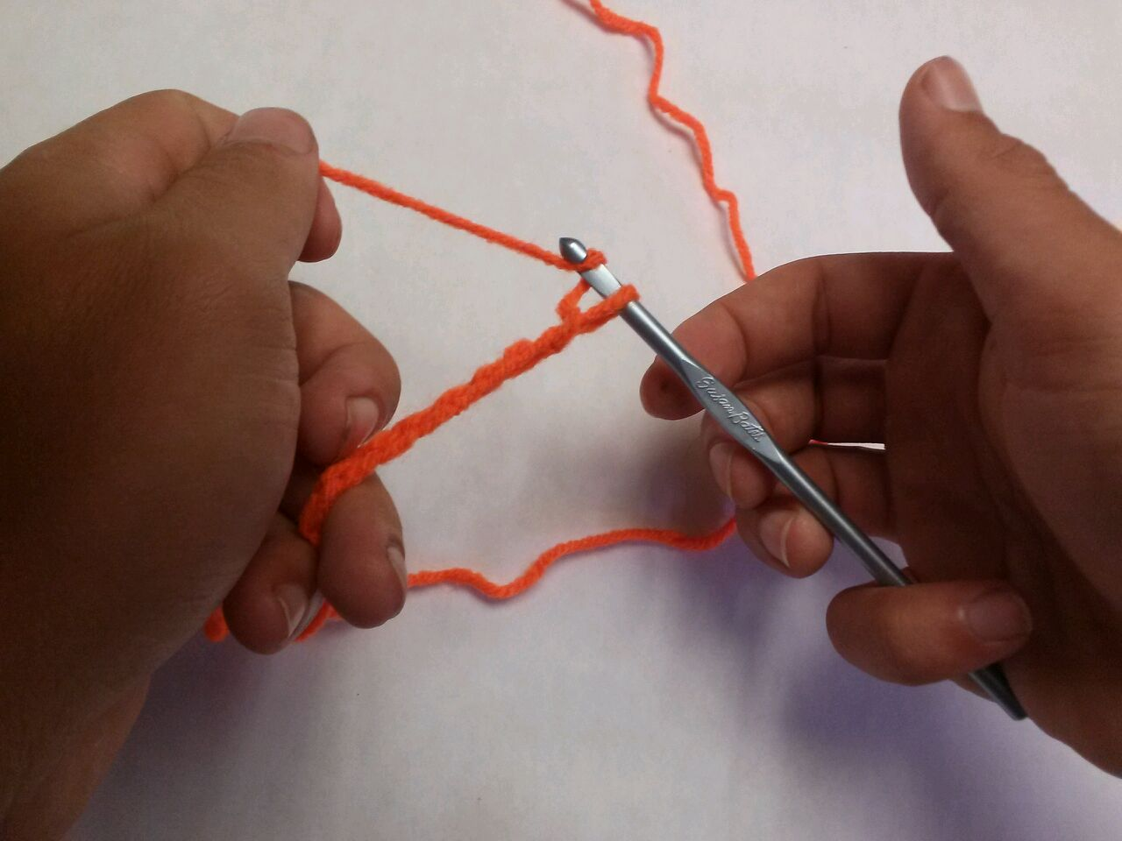

- Once the desired length is obtained, cut the yarn – leave approximately 2-3”, pull the yarn through the last loop to form a knot - this prevents unraveling.
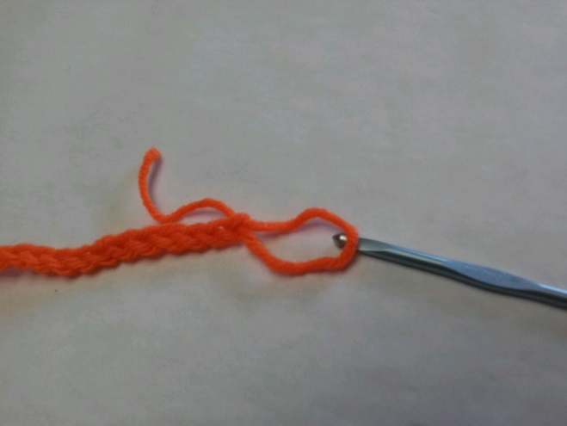
The yarn rope is complete!
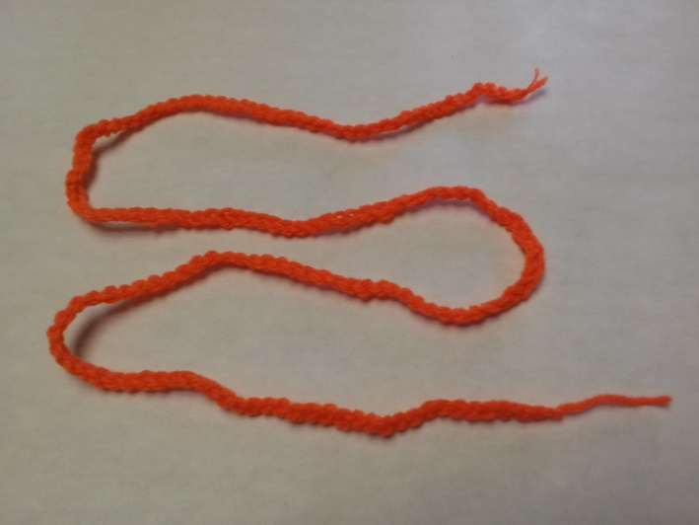

Caution: When using yarn ropes with children, adult supervision is a must!

