
Activity 2: Dance Freeze

intent:
This song engages participants as they integrate perceptual motor skills, movement concepts, locomotor and non-locomotor skills, balance, and active physical play that requires young children to use auditory discrimination skills as they start and stop to music.

OUTCOMES:

Participants will actively participate in the song, responding to movement prompts as they practice and integrate various motor skills.

Participants will record/discuss perceptual-motor skills and movement concepts experienced in the song.

Materials Required:


Song: Dance Freeze, by Angela Russ, CD: Smart Moves 2

(www.ABridgleClub.com)

Music player


Movement prompts (see next page)

Open space (indoors or outdoors) for each participant to move safely

Optional: chart paper and markers (one per table)

Time: 3-4 minutes

Process:
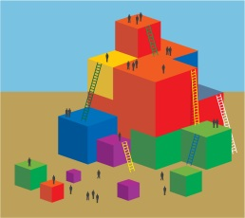
- Prepare participants for movement—check clothing and shoes and push in chairs at tables, along with bags/totes/etc.
- Invite all participants to move to an area with open space and be aware of others/object nearby.
- Introduce the song instructing participants to freeze when the music is off and to listen for a new movement prompt during each freeze segment. (Note: There are 15 music segments, see the next page for movement prompts.) Cue song.
- After the song, ask table groups to record/discuss all the perceptual-motor and movement concepts experienced in the song activity.

OPTIONS:
- Half way through the song, have participants create a new way to move using a variety of perceptual-motor skills and movement concepts.
- Song prompts are suggestions only; change/modify/adapt as needed.
- Advise participants to check their music library for additional start/stop songs or to use any music and start/stop manually. Moving segments should be approximately 20 seconds long.
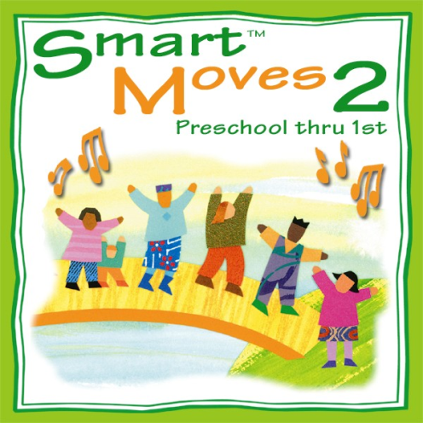
Dance Freeze
CD: Smart Moves 2 by Angela Russ

Lyrics | Movement Cues
Dance when you hear music  And when it stops you freeze  Start dancing when it starts again  Dance freeze, dance freeze, dance freeze | Walk at a half-speed in open space
Musical interlude, followed by a pause – repeats 14 times | Walk quickly and give high-5s
Musical interlude, followed by a pause – repeats 14 times | Step sideways leading with the same foot
Musical interlude, followed by a pause – repeats 14 times | Step sideways leading with opposite foot
Musical interlude, followed by a pause – repeats 14 times | Put one foot in front and gallop
Musical interlude, followed by a pause – repeats 14 times | Turn around, gallop with the opposite foot in front
Musical interlude, followed by a pause – repeats 14 times | Stand and sway your arms gently (little force)
Musical interlude, followed by a pause – repeats 14 times | Stand and sway your arms vigorously (a lot of force)
Musical interlude, followed by a pause – repeats 14 times | Jump side to side with just a little effort
Musical interlude, followed by a pause – repeats 14 times | Jump forward with a lot of effort
Musical interlude, followed by a pause – repeats 14 times | Skip slowly at a high level (hands over head)
Musical interlude, followed by a pause – repeats 14 times | Skip slowly at a high level on a curved pathway
Musical interlude, followed by a pause – repeats 14 times | Jog at a low level on a zigzag pathway
Musical interlude, followed by a pause – repeats 14 times | Move your favorite way at a medium level half speed (half speed is whatever you want it to be)
Musical interlude, followed by a pause – repeats 14 times | Walk slowly back to your seats!

