Time Machine | 
 | intent:  Participants gain experience using the Preschool Curriculum Framework (Volume 2)  to enhance the classroom environment.

OUTCOMES:

Participants will read, reflect upon, and plan using the environmental suggestions listed in the Preschool Curriculum Framework (Volume 2).

 | Materials Required:  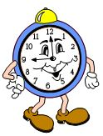  - Handout 3: Environments and Materials  - Handout 4: Time Machine  - (Optional) Back to the Future music  TIME: 10 minutes
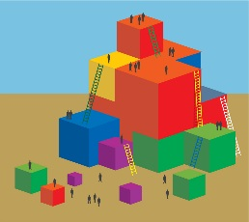 | Process:  - Have participants read Handout 3: Environments and Materials.  - Allow five minutes for table groups to discuss potential ways they might enhance the classroom environment using the ideas from the handout.  - Read the following script:  - Step into your time machine.  - Travel forward six months.  - Look at your amazing, successful program!  - What do you see, hear, and feel that is making the health environment a success?  - Ask participants to represent what they saw in their future classroom by filling out Handout 4: Time Machine (write, draw, etc.)

