Integrating Health Habits | 
 | intent:  Participants read interactions and strategies from the Preschool Curriculum Framework (Volume 2) and share activities that support the development of health knowledge and practices.

OUTCOMES:
Participants will do the following:
- Read interactions and strategies from the health habits section of the Preschool Curriculum Framework (Volume 2)
- Explore health-related items
- Brainstorm for item-based activities that could be used in the classroom to facilitate development of the health foundations
- Share activity ideas with groupmates

 | Materials Required:  Preschool Curriculum Framework (Volume 2)  Handout 7: Integrating Health Habits into Daily Routines  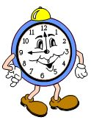  One Health Box per table group—each containing a variety of health items (e.g., toothbrush, sunscreen, apple, carrot, hand sanitizer, tissue, washcloth, hair brush, band aid, etc.)  TIME: 20 minutes
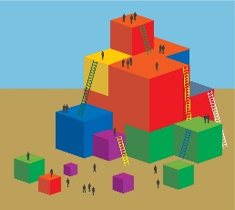 | Process:  - Direct participants to the Health Habits strand section of the Preschool Curriculum Framework (Volume 2)—starting on page 233.  - Point out that there are interactions and strategies listed for each substrand section: Basic Hygiene, Oral Health, Knowledge of Wellness, and Sun Safety.  - Highlight and read one interaction and strategy aloud to the whole group.  - Give participants five minutes to read through more of the interactions and strategies.  - Direct participants to the Health Box on their tabletop. Have them explore the objects and discuss each item’s connection to health with their groupmates.  - Ask participants to take out Handout 7: Integrating Health Habits into Daily Routines.  - Have each participant to select one item from the box and consider how they would use that item to inspire activities that support the development of health knowledge and practices. Remind participants to consider the interactions and strategies they read as they brainstorm these activities.  - Direct participants to write their activity ideas on the handout.  - Have groupmates share their activity ideas with each other.  - OPTIONAL debrief scenarios:  - Allow time for each table group to share their favorite ideas.  - Have table groups write down the health habit foundations being addressed by each idea.  - Have participants think about a specific child in their program that would benefit from targeted support of health foundations.  - How might the ideas they wrote down specifically support this child?

