Food Plate Toss | 
 | intent:  Participants experience a nutrition-based activity that can be used in the classroom.

OUTCOMES:

Participants will reflect on their personal knowledge of nutrition. This activity will help launch module content regarding the nutrition strand, and serve as an example activity for teachers to do with students.

 | Materials Required:  For inside play:  - Drop cloth with food plate on it or marked with colored masking tape (orange, green, red, blue, and purple)  - Grab bag filled with objects and/or pictures representing foods from each food group  - Name cards for each of the five groups (grains, vegetables, fruits, milk, meat and beans)  For outside play:  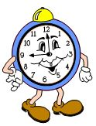  - Sidewalk chalk  - Name cards for each of the five food groups  - Bean bags with pictures of foods on them  TIME: 5 minutes
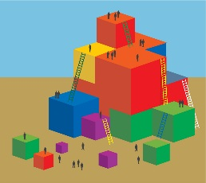 | Process:  - Place the drop cloth on the floor with the food labels clearly displayed.  - Review food group names and contents to remind participants of food plate organization.  - Take out the grab bag and ask four or five volunteers to join you.  - Have the first volunteer blindly reach into the bag and choose one thing to pull out.  - Have the first volunteer hold up the object they chose, showing the whole group.  - Provide support to the volunteer as needed to help them identify the food group the object belongs to.  - Guide the participant to stand on the correct food group (i.e., match the object to the correct food group and stand with the object on the drop cloth).  - Repeat these steps for the remaining volunteers.  - Guide participants to discuss what ways they might front-load, enhance, and expand this activity to meet the needs of all the children in their programs.  - Ask participants to analyze which foundations in the Nutrition strand might be supported by this activity.  - Invite participants to share their ideas with the whole group or have two groups join up to share their ideas with each other.  - Have participants return to their tables.  - Give participants the following tip: Introduce the food plate with another activity or book—such as The Beastly Feast by Bruce Goldstone—one or two days prior to doing this activity in your classroom.

