Rhythm Sticks



**intent:**

This activity engages participants in a rhythmic activity that blends perceptual motor skills, movement concepts, locomotor skills, and active physical play in a movement pattern that includes directional cues, pathways, crossing midlines and object manipulation.

**OUTCOMES:**

Participants will:

* Actively participate in a rhythmic activity, responding to movement prompts as they integrate perceptual motor skills, movement concepts, locomotor skills, and active physical play as they travel on a directional pathway
* Tap rhythm sticks to the beat of the music in a variety of directional locations.
* Discuss how a rhythmic manipulative activity can enhance directional awareness through physical activity while crossing midlines.

**Materials Required:**

* MCBS00539A0000[1]Rhythm sticks, two per participant (or use wooden dowels)
* Yarn, painter’s tape, pair of scissors
* Music player and music (a high energy song with a beat – trainer’s choice, suggestion: *I Like to Move It*, Disney movie – Madagascar)
* Movement prompts (see next page)
* Open space for each participant to move safely

**Time:** 7-8 minutes

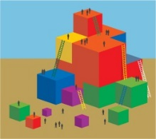**PREPARATION:**

* Prior to activity, prep floor by taping yarn (or use painters tape) in straight, curved and zigzag pathways (see examples below).
* Set rhythm sticks on tables, two per participant.

**Yarn pathway**  **Painters tape pathway**

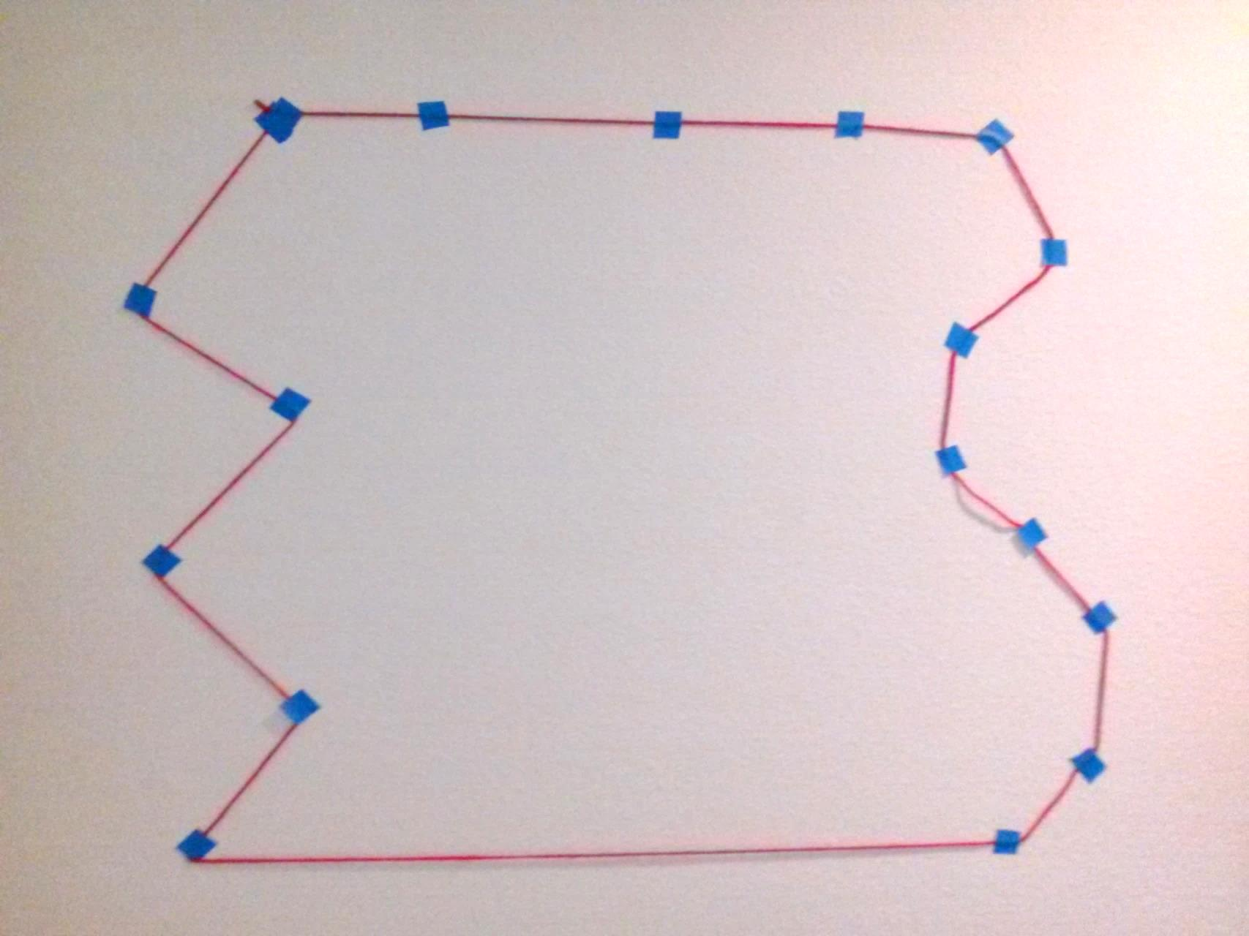



**Process:**

1. Prepare participants for movement: Pass out two rhythm sticks per participant and move to yarn/tape pathway. Be aware of others and objects nearby.
2. Inform participants they will be traveling on the pathway around the area as they tap their rhythm sticks to a variety of movement prompts. When the music is off, stop in place and listen for a new movement prompt.
3. Cue music and begin moving in a clockwise fashion – see movement prompts below. Individual music segments should be approximately 30-40 seconds in length.
4. After activity, discuss how directional cues (right/left, side to side, up/down, forward,

and sideways) integrated with rhythm and object manipulation can enhance crossing midlines (tapping side across left and right sides of the body; tapping high and low crossed top and bottom; tapping front to back crossed in front and in back of the body; side stepping engaged right/left and top/bottom midlines) for an inclusive movement experience.

|  |
| --- |
| ***Rhythm Sticks Movement Prompts*** *(30-40 seconds)* |
| *When you hear the music, begin walking and tapping sticks together to the beat in a clockwise fashion. Make sure your feet follow the pathway on the floor.* |
| *Walk and tap sticks from side to side, begin tapping on the right side first.* |
| *Turn around, walk and tap sticks high and low.* |
| *Turn around, walk and tap sticks front and back.* |
| *Now face your body toward the center of the area. Step sideways leading with your right foot and tap your sticks up high by your right shoulder.* |
| *Still facing inward, step sideways leading with your left foot and tap your sticks down low by your left knee.* |
| *Can you do a disco step tap? Step sideways leading with your right foot and tap your sticks up high by your right shoulder. Bring your left foot next to your right foot and tap your stick down low by your left knee. Keep repeating.* |

**OPTIONS:**

* Instead of using a single song, use a variety of music genres that contain different rhythm, beat, tempos, etc.
* Ask participants for a movement pattern everyone can do.
* Activity can be done outside on a chalk pathway.
* Smooth wooden dowels or new pencils (unsharpened) may be substituted for sticks.
* For safety, moving backwards is not recommended for this activity.