
Putting It All Together

intent:
This activity is designed for participants to incorporate the information they learned in the presentation and design an activity for teachers to do with children.

OUTCOMES:
Participants will consider all the information about the three substrands and design a perceptual motor skills and movement concepts activity.


Materials Required:
- Participants’ notes from the module presentation
- Perceptual motor skills and movement concepts handout
- If available, Preschool Learning Foundations, Volume 2 and/or Preschool Curriculum Framework, Volume 2

- Ropes, scarves, bean bags, beach balls, pool noodles, jump ropes, and any other materials to enhance this activity

Time: 20-30 min. depending on the size of group. Give each table 10 minutes to design an activity and allow each table to demonstrate the activity to the rest of the group for a few minutes.

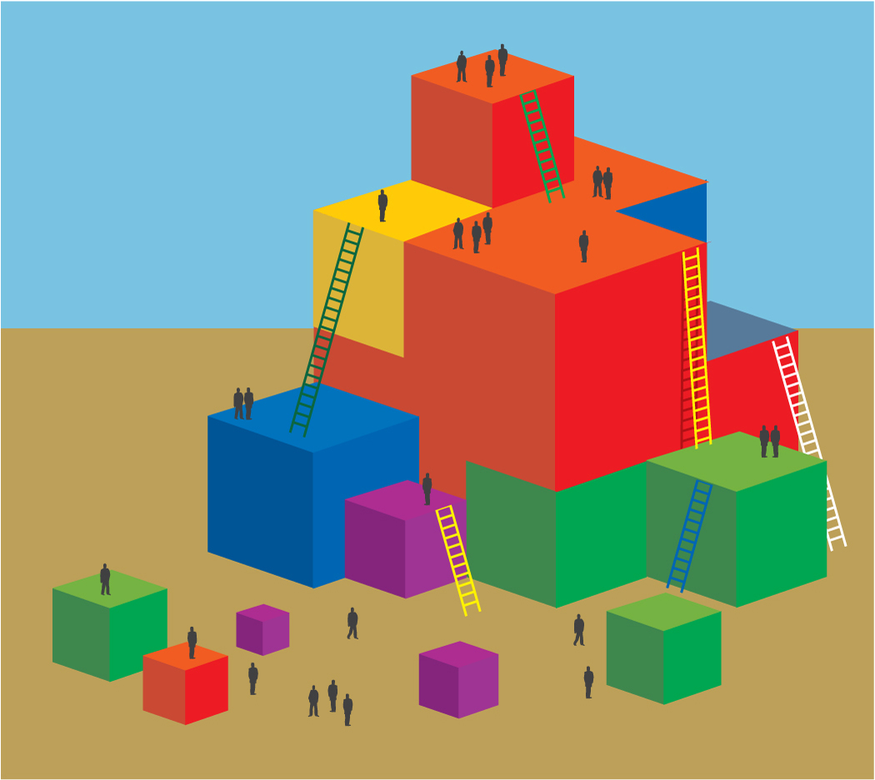
Process:
- Participants review the module information.
- Participants choose the materials they want to use (bean bags, ropes, etc.).
- They should consider strategies for English language development and accommodations for children with disabilities.

OPTIONS:
- The whole group can participate in the activities designed by the different groups.
- Each table can be given a bag of materials to use in their activity.

