
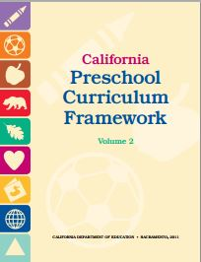
Physical Development Domain
Perceptual-Motor and Movement Concepts
1.0 Body Awareness

Idea #1  (Write brief description.)  Materials  (List prop/equipment/materials/music needed.) | List 1-2 Interactions and Strategies your idea connects with.
Idea #2  Materials | List 1-2 Interactions and Strategies your idea connects with.
Idea #3  Materials | List 1-2 Interactions and Strategies your idea connects with.
©2014 California Department of Education (CDE) with the WestEd Center for Child & Family Studies.

