
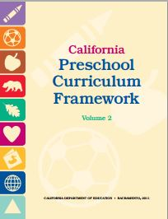
Physical Development Domain
Perceptual-Motor and Movement Concepts
2.0 Spatial Awareness

Interactions and Strategies | Page #  (PCF, Vol. 2) | Notes/Ideas
Set up obstacles courses that encourage children to go over, under, and through objects. | p. 183
Provide opportunities for children to experience moving at different levels of body positioning, ranging from high to low. | p. 183
Provide games for children to explore changing the size of their bodies. | p. 183
Play games that allow children to move around with objects balanced on different parts of their body. | p. 183
Provide pushing and pulling games with peers. | p. 183
Play games that require two to three children to work together to transport a large, lightweight object. | p. 183
Use dancing and musical games to promote the development of spatial awareness and body control. | p. 183
Use positional-concepts vocabulary within the natural context of daily routines. | p. 184
Have children participate in cleanup routines by putting away toys. | p. 184
Engage children in helper roles by per-forming “heavy work” activities. | p. 184

Narrate or ask questions about children’s play using positional-concepts vocabulary in English and the child’s home language. | p. 184
Engage children in songs and rhymes with body movements or spatial concepts. | p. 184
Reinforce spatial concepts when reading or looking at books. | p. 184
Use props or play objects to guide children in positioning their bodies. | p. 185
Use the child’s home language to introduce spatial-concepts vocabulary. | p. 185
Provide alternative ways for children with physical disabilities or other special needs to learn spatial concepts. | p. 185
Provide additional cues and assistance as needed to ensure safety for children who have spatial-awareness challenges. | p. 185

