Perceptual-Motor and Movement Concepts
2.0 Spatial Awareness
Spatial Awareness Vignette Worksheet

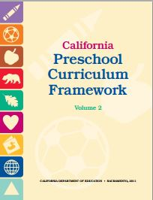


Spatial Awareness Vignette
©2014 California Department of Education (CDE) with the WestEd Center for Child & Family Studies.
(Write a short vignette that involves spatial awareness below.)

Teachable Moment or Planning Learning Opportunities
(Write key elements that are identified in the vignette below.)

