
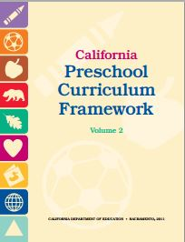
Physical Development Domain
Perceptual-Motor and Movement Concepts
3.0 Directional Awareness

Interactions and Strategies | Page #  (PCF, Vol. 2) | Notes/Ideas
Provide opportunities for child-initiated play in areas with open space. | p. 187
Provide safe environments in which children can climb up and down. | p. 187
Encourage children to move in different directions and in different types of pathways (e.g., straight, curved, or zigzag) during group movement games. | p. 187
Design activities for children to practice moving alongside or in a line with other people. | p. 187
Play games that require children to coordinate moving with others to manage a physical object or prop. | p. 188
Provide opportunities for children to move and use their bodies with force. | p. 188
Provide opportunities for children to move and use their bodies lightly. | p. 188
Engage children in two-handed play activities. | p. 188
Position drawing activities vertically. | p. 188
Provide pretend-play activities to reinforce directional concepts. | p. 189
Use the child’s home language for introducing directional-concepts vocabulary. | p. 189
Adapt movement experiences as needed for children with physical disabilities. | p. 189

