
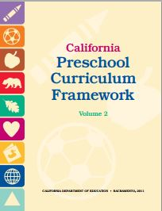
Physical Development Domain
Perceptual-Motor and Movement Concepts
1.0 Body Awareness

Interactions and Strategies | Page #  (PCF, Vol. 2) | Notes/Ideas
Use multisensory teaching strategies to reinforce children’s learning. | p. 179
Use body-parts vocabulary in the child’s home language. | p. 179
Use alternative communication methods, as appropriate, to teach body-parts vocabulary. | p. 179
Use body-parts vocabulary in the natural context of daily living activities and child-initiated play. | p. 179
Introduce body-parts vocabulary during structured group games. | p. 179
Engage children in singing and movement activities to teach body parts. | p. 179
Encourage children to identify and describe body parts in books or in pictures of themselves and family members. | p. 180
Provide opportunities for dress-up play. | p. 180
Provide opportunities for children to see external representations of their bodies. | p. 180
Provide constructional play for children to build or put together body parts. | p. 180
Ask children to describe their drawings of people. | p. 180
©2014 California Department of Education (CDE) with the WestEd Center for Child & Family Studies.

