 Exploring the Research: Bibliographic Notes



**intent:**

Become familiar with the Self strand.

**GOAL:**

Participants will become familiar with and discuss the bibliographic notes section of the Self strand

MCBS00539A0000[1]****

**Materials Required:**

* Preschool Learning Foundations, Volume 1, pp. 21-26

**Time:**  15 minutes

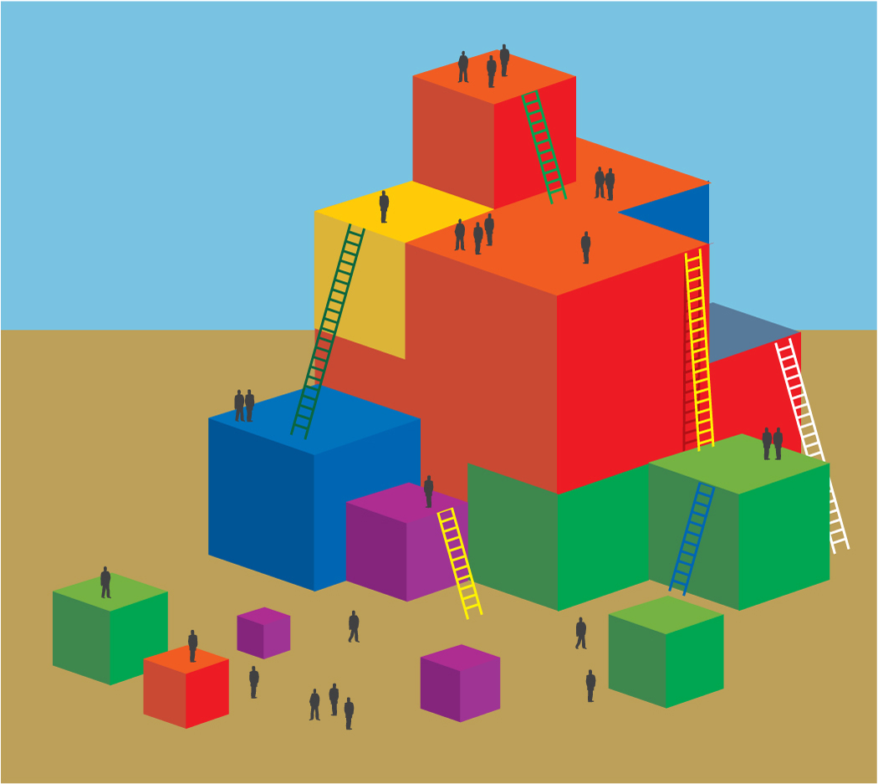

**Process:**

* Ask participants to turn to the bibliographic notes section of PLF, Volume 1, pp. 21-26.
* Have each participant at each table select to work on a different sub strand.
* Ask participants to read through their section and note something they have noticed in their own work with children.
* Invite participants to share out their observations with their tablemates.