 Integrated Brain



**intent:**

Experience an analogy for supporting social-emotional development throughout the program day.

**GOAL:**

Participants work as teams to create “brains” that will experience a variety of social-emotional experiences supporting development.

**Materials Required:**

* ****MCBS00539A0000[1]Participant half-sheets with strategies (From Theory to Practice activity)
* Duct tape
* Confetti
* Chart paper

**Time:**  10 minutes

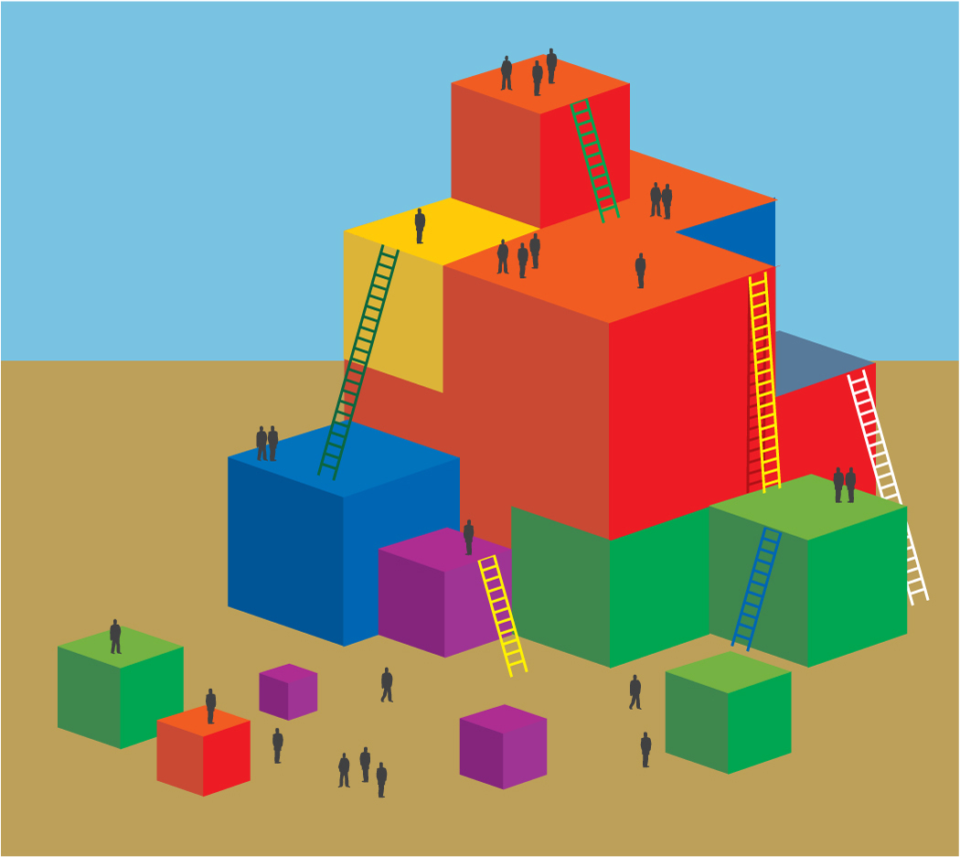

**Process:**

|  |
| --- |
| Prior to Training   1. Prepare chart paper with a sample daily schedule. Put double-sided tape in each section so participants can stick the half sheets of paper onto the daily schedule.   During Training   1. Ask participants to choose two of the interactions and strategies they listed on the half-sheets of paper and to place them on the daily routine where they would most likely be used. 2. Provide each table group with a ball of duct tape (sticky side out) and a bowl of confetti. (Do this while table groups are taping their interactions and strategies to the daily routine.) 3. Read the quote from the Developing Brain slide, *“The developing brain is not neatly divided into separate areas governing learning, thinking, and emotions. Instead, it is a highly interconnected organ with different regions influencing, and being affected by, the others*” (PCF, Vol. 1, p. 39). 4. Explain that we will share a modeling experience on how the brain is interconnected and grows and changes based on a variety of experiences and social interactions. 5. Say to participants:    * We will have two duct tape “brains”: my brain that was not lucky enough to experience the rich daily experiences on the chart paper and all your “brains”—which represent the children the classroom—that will get to experience the daily routines.    * Choose one person in the group to hold your duct tape brain and follow along with me.    * First, let’s look at arrival time. It looks like in our daily routine teachers will (fill in the blank with whatever the strategy is taped here). The children in this class start the day with a rich experience. Go ahead and dip their brains in the confetti since their experience is stuck in their “brain.” My brain doesn’t get that.    * Second, let’s look at the next time slot—it’s classroom meeting. It looks like your students will get to (share a story or trade-out for interaction and strategy listed on chart paper). Dip your brains again, they are building on the experience they will have forever in their brains. 6. Continue this process until you have gone through the whole program day. You can dip the unlucky trainer brain once or twice wherever it makes sense. But in the end, you want to have a vast difference between the unlucky brain and the lucky brains of the children in this classroom. 7. Compare the table group brains of the potential students (after all the strategies in daily routine have been read) to the unlucky trainer brain. 8. Ask participants: What do you notice?    * The children’s brains who had integrated experiences of social emotional development and interactions with teachers and peers have a variety of experiences, colors, and connections to utilize. Their knowledge base to pull from is much richer.  * Invite table groups to talk with each other about their “take-away” messages. Ask for groups to share out any aha! moments they might have experienced. |