
Performance or Learning

intent:
Learn the difference between a performance orientation and a learning orientation.

GOAL:
Participants will understand the differences between a performance orientation and a learning orientation and how those differences impact children’s learning


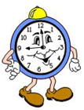
Materials Required:

Handout 3: Performance or Learning

Chart paper

Various colored writing and drawing tools

Time: 15 minutes
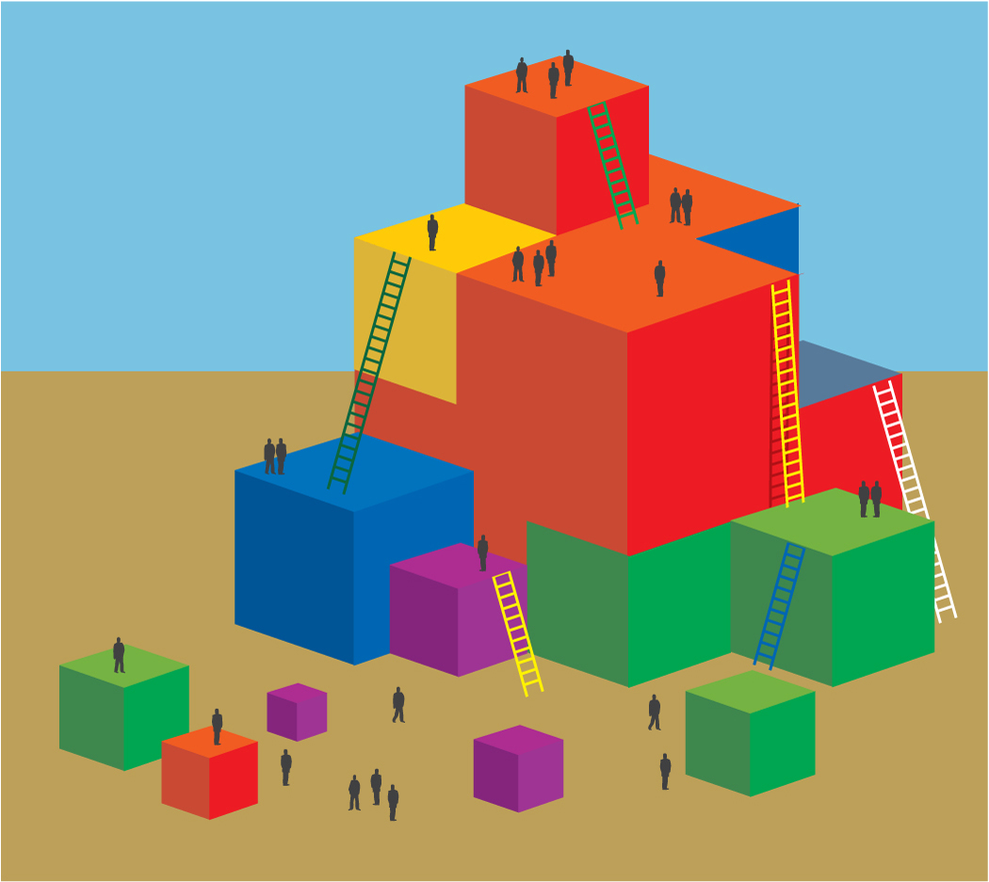
Process:

- Ask participants to silently read Handout 3: Performance or Learning.
- As a table, create a visual to represent the characteristics of the two different orientations and the influence each has on children’s learning.
- Have students hang their work on the wall in the designated area when they are done.
- Invite comments and feedback.

