Self-Regulation Interactions and Strategies
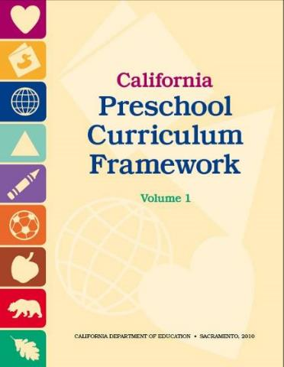
Preschool Curriculum Framework, Vol. 1, pp. 49-52

- Use appropriate stimulating aesthetic elements
- Use soothing colors
- Use soft textures
- Avoid visual clutter

- Eliminate background noise
- Help all children focus more
- Separate noisy areas from quiet areas
- Use cues that help children understand it’s getting too loud in the classroom

- Observe individual children closely
- Identify where that child needs the most adult support
- Support children with problem solving
- Assist them with using language to express emotions

- Model behavior and attitude towards others
- Communicate in a respectful way
- Model enthusiasm for persisting at a task until finishing
- Model emotional self-control

- Maintain developmentally appropriate expectations for preschool children’s behavior
- Plan brief large group activities
- Provide longer periods of self-initiated activities
- Help children manage complex tasks
- Ensure expectations for emotional self-control and behavior control are appropriate for the child’s age or developmental level
- Supply plenty of play materials

- Guide and coach children’s behavior
- Use a positive tone to prompt problem solving
- Give brief instructions
- Give reminders

- Reinforce Children’s good choices and link their actions to positive outcomes
- Acknowledge children’s efforts
- Draw attention to specific ways a child’s behavior made an experience successful
- Express pleasure

- Provide a consistent but flexible daily routine
- Facilitate trust and focus with consistency in routines
- Allow children to anticipate what comes next
- Enable children to better regulate

- Alternate between active and quiet activities
- Experience more positive behavior
- Increase children’s ability to fully engage with their learning environment

- Time group experiences
- Offer brief group experience
- Avoid disruptive behavior by not ignoring a group’s need for a transition
- Enable more cooperation with shorter large group time
- Use visuals to help children stay interested

- Introduce children to relaxation exercises
- Assist children in self–reflection with exercises
- Help children build self-regulation
- Use calming activities
- Soothe a frustrated child by drawing attention to the body’s response to stress

- Prepare “private” spaces for children
- Use pillows, blankets, stuffed toys, or a small table for a quiet activity
- Provide area that is inviting
- Create space away from noisy areas

- Plan developmentally appropriate transitions
- Maximize and encourage constructive participation by planning
- Sing songs during transitions

- Play games with rules
- Help children learn to focus and regulate their impulses
- Use simple bingo games, and or matching games
- Use active games in the play yard such as Simon Says, or Red Light, Green Light

