Supplemental Resources for Download

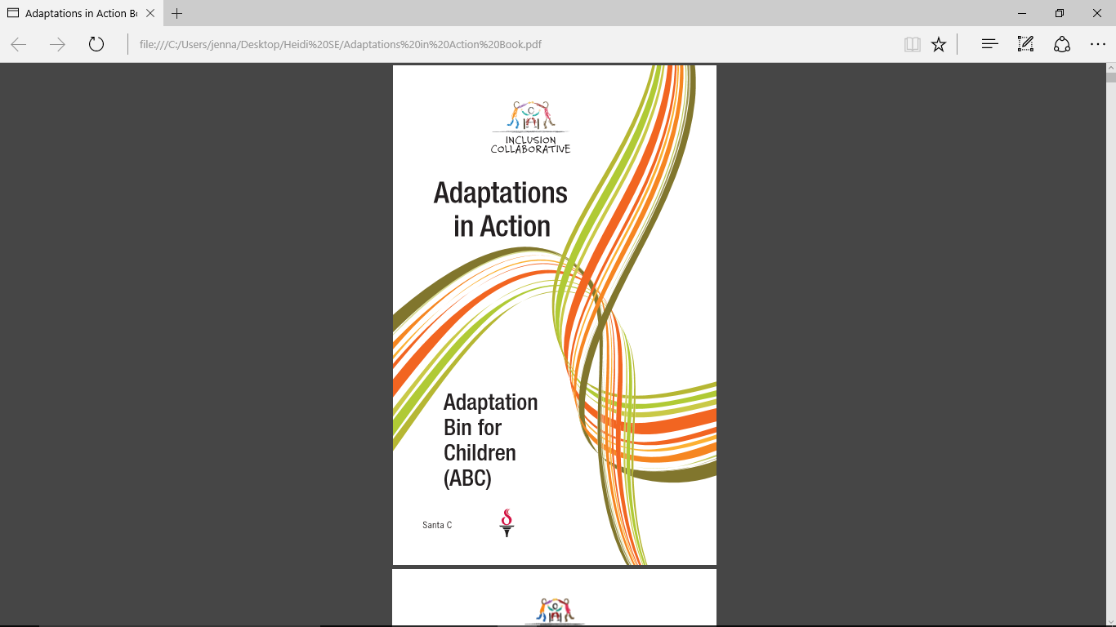
TK teachers may also consider downloading a free guide, Adaptations in Action: Adaptation Bin for Children (Nielsen 2009), to support students with disabilities in the classroom. (TK Guide, p. 54)

Nielsen, L. 2009. Adaptations in Action: Adaptation Bin for Children (ABC). San Jose, CA: Santa Clara County Oﬃce of Education. http://www.sccoe.org/depts/students/inclusion-collaborative/Documents/Adaptations%20in%20Action%20Book.pdf


Books representing mixed-race families

50+ Picture Books about Mixed Race Families
For a full list of over 50 book recommendations, go to http://coloursofus.com/picture-books-about-mixed-race-families/

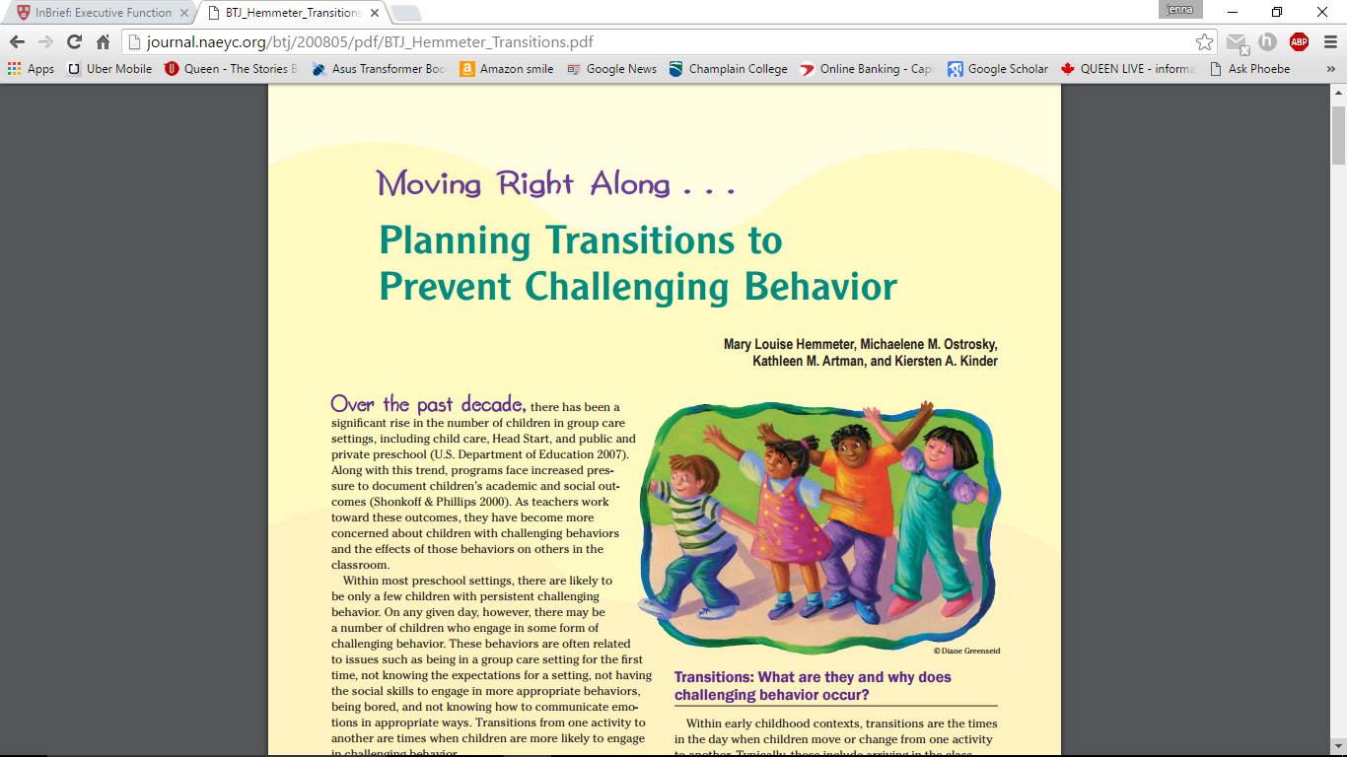
Moving Right Along…Planning Transitions to Prevent Challenging Behavior
Great article with both general tips and additional guidance for children who need more support.
Download the complete article from: http://journal.naeyc.org/btj/200805/pdf/BTJ_Hemmeter_Transitions.pdf

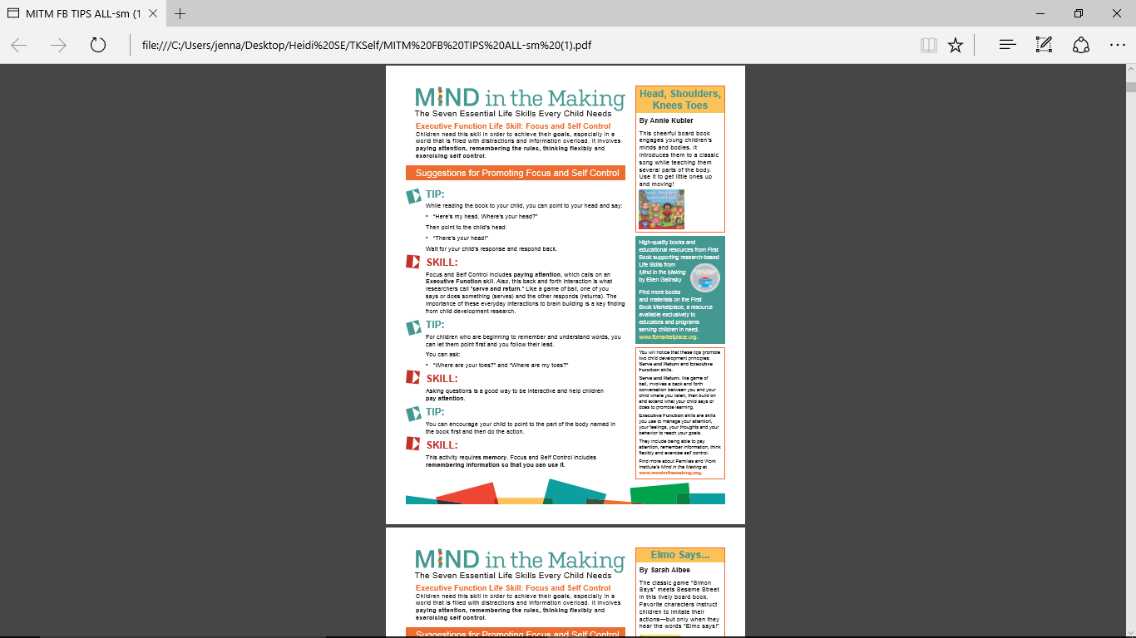
Mind in the Making (MITM), developed by Families and Work Institute (FWI), is an unprecedented effort to share the science of children’s learning with the general public, families and professionals who work with them. Based on Mind in the Making: The Seven Essential Life Skills Every Child Needs (HarperCollins, 2010) by Ellen Galinsky, president of FWI, its mission is to promote Executive Function Life Skills in adults and through them in children in order to keep the fire for learning burning brightly in all of us.
Mind in the Making has partnered with First Book, a nonprofit social enterprise that provides books and educational materials for educators serving children in need, to curate a groundbreaking 'Mind in the Making' Book Collection that combines children's books with tips for building Seven Essential Life Skills.
Download complete set of First Book Tip Sheets from http://www.readyatfive.org/download-document/about-raf/839-mitm-fb-tips-all-sm/file.html
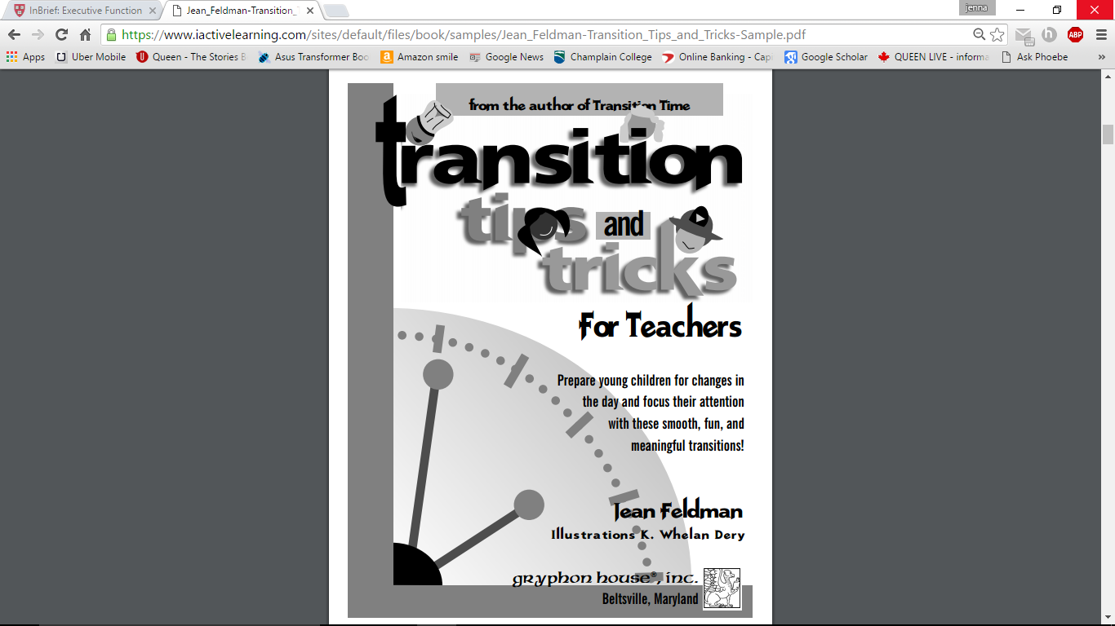
Transition Tips and Tricks for Teachers
Free 26 page sample download from https://www.iactivelearning.com/sites/default/files/book/samples/Jean_Feldman-Transition_Tips_and_Tricks-Sample.pdf

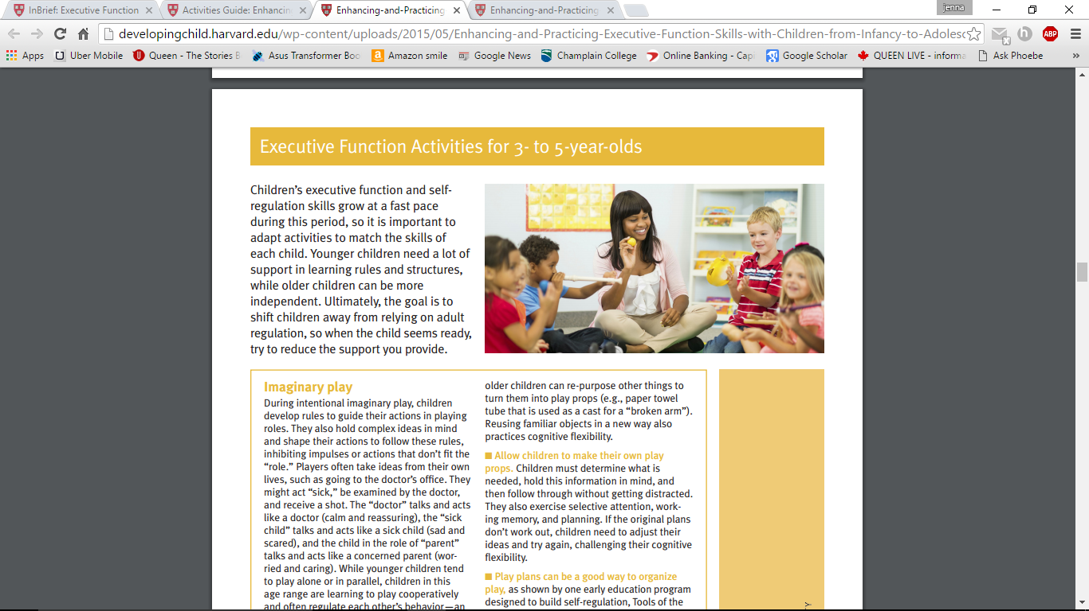
Executive Function and Self-regulation (EF/SR) skills provide critical supports for learning and development, and while we aren’t born with these skills, we are born with the potential to develop them through interactions and practice. This 16-page guide (available for download, below), describes a variety of activities and games that represent age-appropriate ways for adults to support and strengthen various components of EF/SR in children.
Each chapter of this guide contains activities suitable for a different age group, from infants to teenagers. The guide may be read in its entirety (which includes the introduction and references) or in discrete sections geared to specific age groups.” Harvard Developing Child
Download from http://developingchild.harvard.edu/wp-content/uploads/2015/05/Enhancing-and-Practicing-Executive-Function-Skills-with-Children-from-Infancy-to-Adolescence-1.pdf

Even more resources for after this session

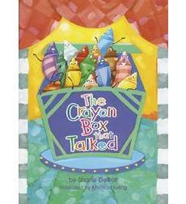
The Crayon Box Talked by Shane Derolf
After overhearing some crayons in toy store complaining about one another, a little girl decides to buy them all and take them home. The girl picks up the colors one by one and draws. When the crayons see the picture they have all helped create, they realize that beautiful things can happen when everyone works together.

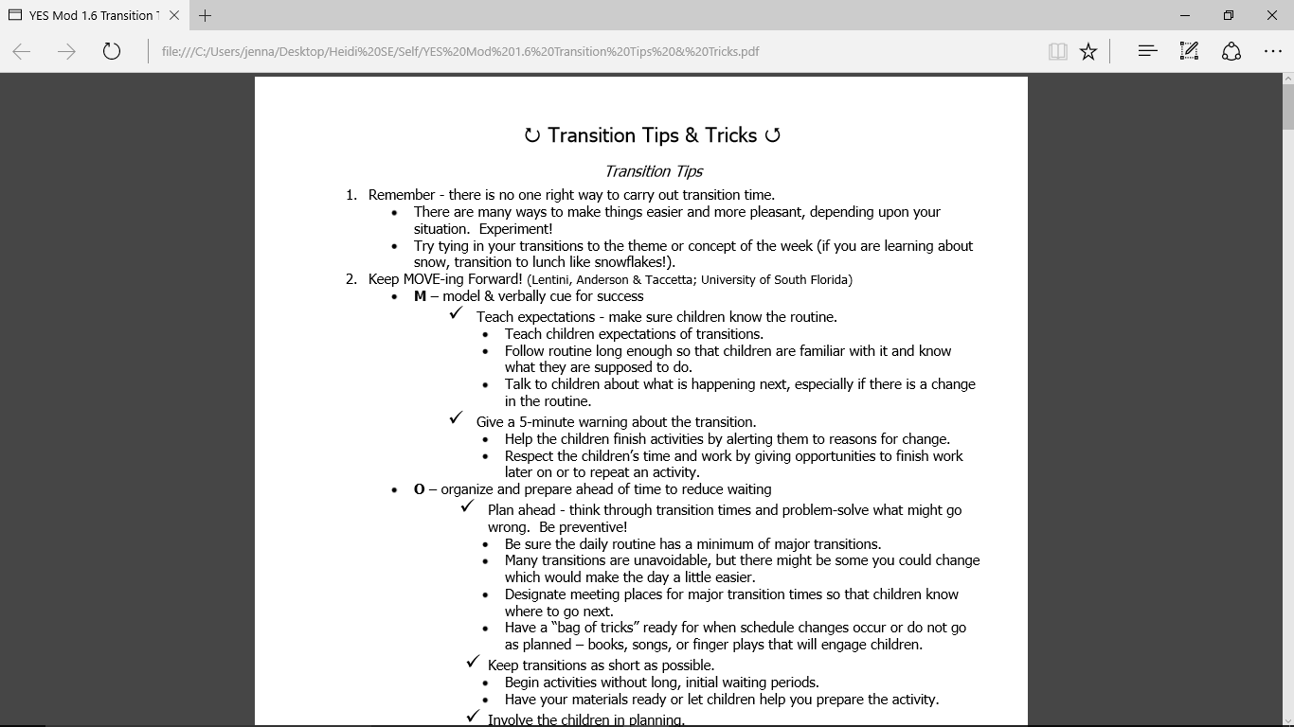
Transition Tips and Tricks
Downloadable resources from Iowa State University http://teamtn.tnvoices.org/sites/teamtn/files/Mod%201.6%20Transition%20Tips%20&%20Tricks.pdf

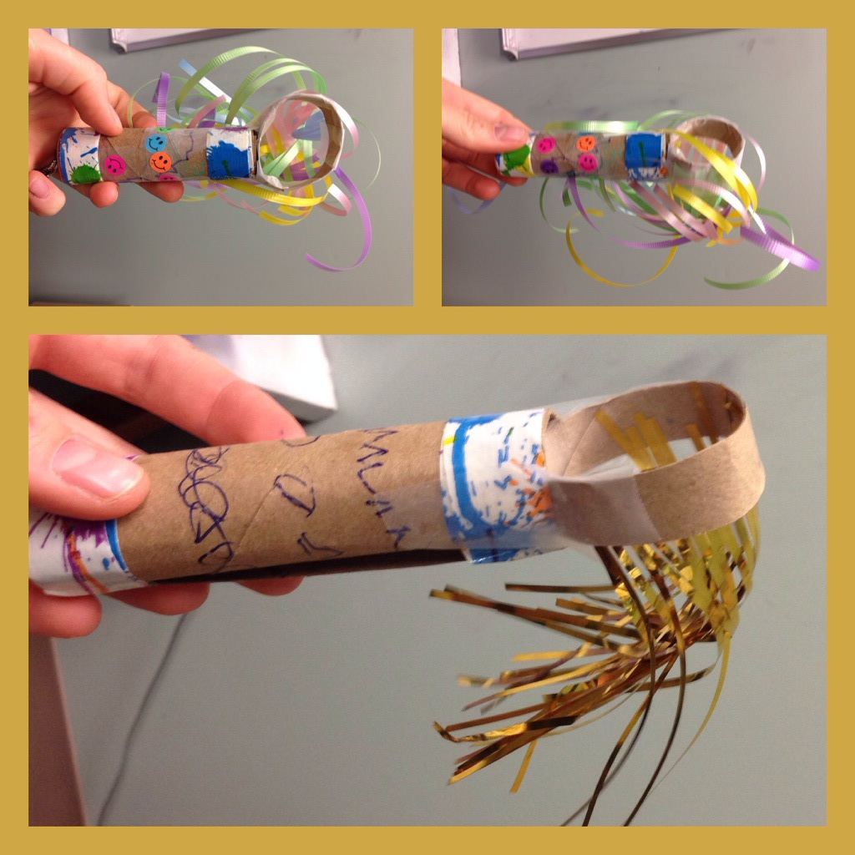
How to Make a Breathing Wand can be downloaded from https://kristinamarcelli.wordpress.com/2014/05/10/make-your-own-mindful-breathing-wand/

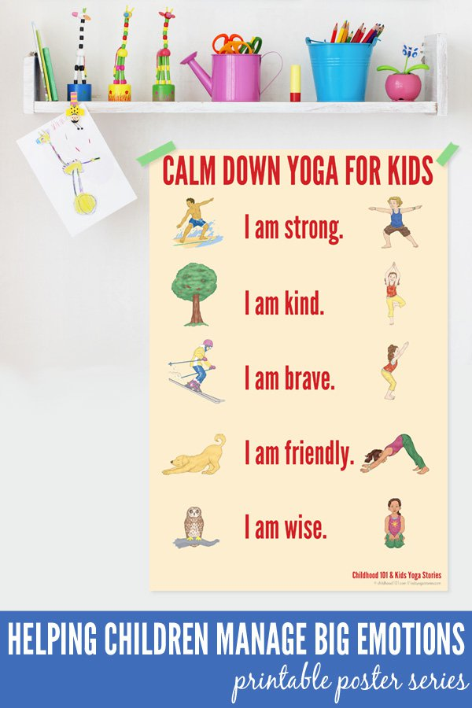

Calm Down Yoga for Kids

See details http://childhood101.com/2015/04/yoga-for-kids/

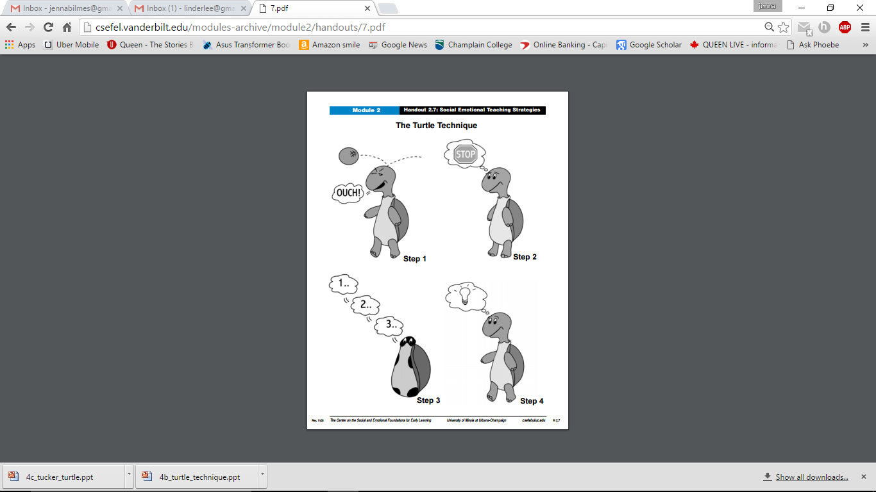
The Turtle Technique
Details and resource for creating a Tucker Turtle book. Many additional tools and resources to support Social-Emotional Development skills. http://csefel.vanderbilt.edu/resources/strategies.html

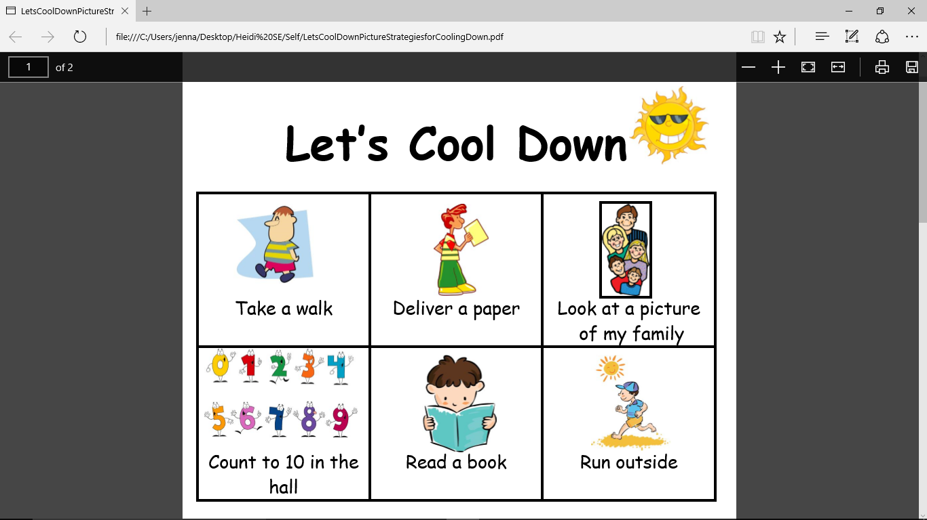
Let’s Cool Down
Picture strategies for cooling down. Available from https://www.teacherspayteachers.com/Product/Lets-Cool-Down-Picture-Strategies-for-Cooling-Down-427516

