 Idea Map



**intent:**

Learn the significance of both teacher/child relationships and interaction strategies to support TK student success.

**GOAL:**

Table groups will create an “idea map” based on talk by Dr. Ross Thompson.

MCBS00539A0000[1]

**Materials Required:**

* Ross Thompson–Social and Emotional Foundations of TK Part 4 (video provided)
* White chart paper
* Multi-colored drawing and writing instruments
* Tape or other wall fastener

**Time:**  25 minutes

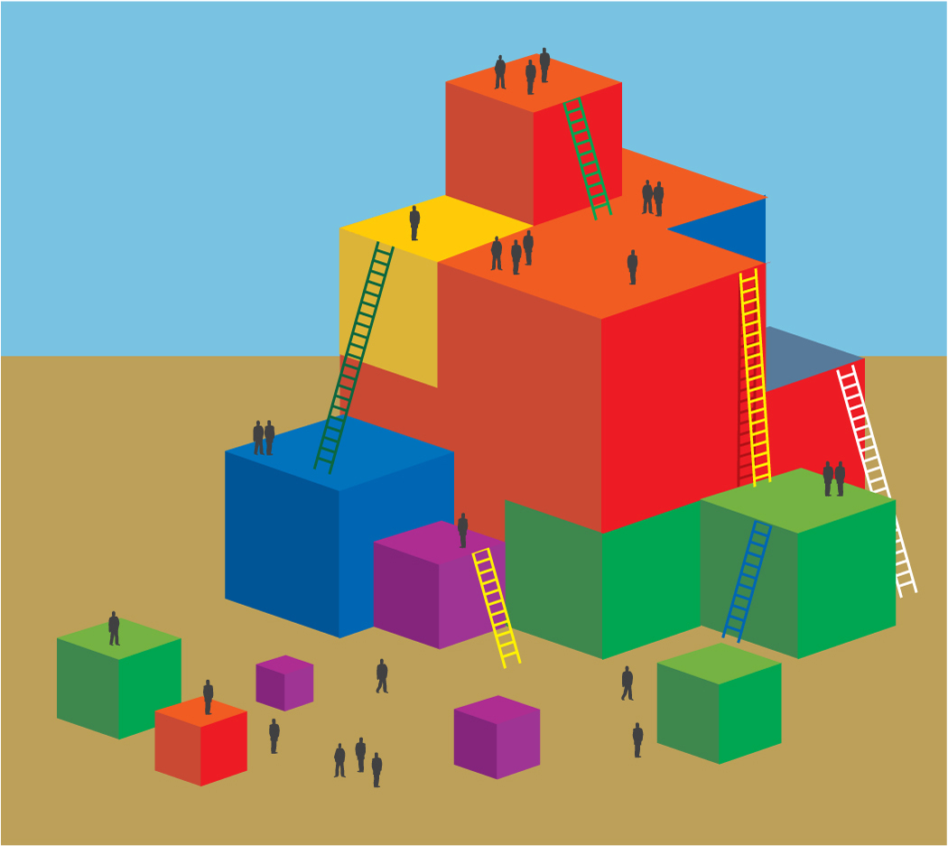

**Process:**

* Participants view a video with Dr. Ross Thompson addressing teacher/child interactions in TK.
* Each table creates an idea map summarizing key points of the talk. Encourage the use of both graphics and words in any desired format.
* The lecture (7 minutes) covers two topics: 1) why teacher-child relationships are important, and 2) teacher-child interactions.
* The video will pause at the end of the first section. Participants have five minutes to begin the group idea map. At the end of the video, five additional minutes are available to complete the map. (Keep the work times very brief. Extend the second work time to no more than 7 minutes.)
* At the end of the work time, participants hang their maps on the walls.
* Invite participants to do a “wall walk” to see how other table groups addressed the content of the lecture.