 I Am Learning



**intent:**

Use the *California Preschool Learning Foundations, Volume 1* to learn the development of Interactions with Peers from 48 to 60 months.

**GOAL:**

Participants explore the foundations and create a poster of the developmental highlights of Interactions with Peers from 48 to 60 months in the area of Interactions with Peers.

MCBS00539A0000[1]

**Materials Required:**

* *California Preschool Learning Foundations (PLF), Volume 1*, pp. 12-13
* Chart paper
* A variety of colored writing and drawing materials
* 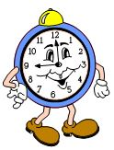A variety of craft items such as glue, yarn, tissue paper, glitter, fabric scraps to illustrate the “child.”

**Time:**  15 minutes

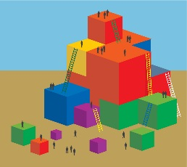

**Process:**

* Participants look at how children’s peer interactions develop from 48 to 60 months and represent that development on a poster.
* Each table group creates one or two children on the chart paper.
* Participants read the foundations for Interactions with Peers in the PLF, Volume 1, pp.12-14 and add notes about children’s development in this area to their poster.
* Participants hang their work on the wall when finished.
* invite participants to take a wall walk to see how different groups represent this growth.