 Theory to Practice Treasure Hunt



**intent:**

Explore strategies to support group participation/cooperation and responsibility

**GOAL:**

Participants research strategies to support group participation cooperation, and responsibility.

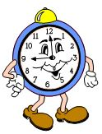MCBS00539A0000[1]

**Materials Required:**

* Handout 5: Treasure Hunt
* Strategy cards

**Time:**  20 minutes

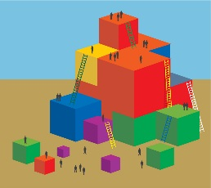

**Process:**

* Hang strategy cards on the walls throughout the room.
* Participants take out Handout 5: Treasure Hunt and pen.
* Explain the strategy cards posted around the room are available to answer questions.
* Show one of the strategy cards as an example so they know what they are looking for.
* Participants share out answers after returning to their table.

# Theory to Practice

# Teach Children Social Skills

* Teachers support interactions with peers by helping children to learn social skills needed to get along (*California Preschool Curriculum Framework (PCF), Volume 2,* p. 60).
* Teachers guide children to understand other people’s feelings and needs and are encourage them to feel empathy and caring (*California Preschool Learning Foundations (PLF), Volume 1*, p. 4; PCF, Volume 1, p. 65; *Developmentally Appropriate Practice* (DAP), p. 199).
* Provide positive ways of solving problems, settling disputes and keeping interaction fair and inclusive without interfering unnecessarily (PLF, Volume 1, p. 28; PCF, Volume 1, p. 65; DAP, p. 199).

# Provide Opportunities to Interact

* Teachers contribute to the development of social skills by encouraging shared activities with friends and other peers and a well-designed environment (PCF, Volume 3, p. 60; PLF, Volume 1, p. 4).
* Teachers should help children who need assistance to find play partners and should teach children proactive strategies for entering and participating in social activities (DAP, p. 199).

# The Role of Play

* Play is an essential cornerstone of healthy social and emotional development in early childhood and contributes to the skills necessary for adjustment to and success in school (PLF, Volume 1, p. 4).
* “Play” Includes social play with others, play with materials, and games with rules (PLF, Volume 1, p. 4)
* “Active learning through purposeful play is important to the development of the child’s brain” (*Transitional Kindergarten Implementation Guide*, p. 41).