 Reflect and Plan



**intent:**

Reflect on current practices and plan for implementation of a new practice.

**GOAL:**

Participants reflect on their strengths and areas for future development, as well as identify a child who might need extra attention.

MCBS00539A0000[1]

**Materials Required:**

* Handout 6: Reflection and Planning for Teacher-Child Interactions

**Time:**  10 minutes

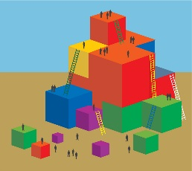

**Process:**

1. Using Handout 6, remind participants that this reflection is for their own use and will not be shared.
2. Participants reflect on their own practices and mark themselves somewhere on the continuum. (Encourage them to circle one of the suggested strategies to focus on over the next few months, and reflect on the children in the classroom to identify any child who may profit from additional interactions.)

Note: Items on the list are based on the content of Dr. Ross Thompson’s video and our other resources.