 Make and Takes



**intent:**

Learn to make simple tools to support social interactions.

**GOAL:**

Each participant creates one of a variety of tools to support social interactions

MCBS00539A0000[1]

**Materials Required:**

* Various colored drawing tools, construction paper, chart paper, poster board, copy paper, butcher paper, glue, tape, stapler, scissors, brads
* Make and Take handout packet
* Make and Take project signs

**Time:**  30 minutes

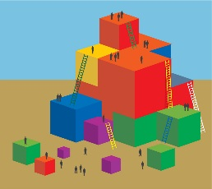

**Process:**

* + - Participants remove all personal items from their table. Trainer places one project sign on each table.
    - Participants take out the Make and Take packets, select one project, and go to the designated table.
    - Trainer mention that there are a variety of materials on the front table to use for their projects.
    - Provide 20 minutes for group to create their projects.
    - Participants share out their work for the final 10 minutes.