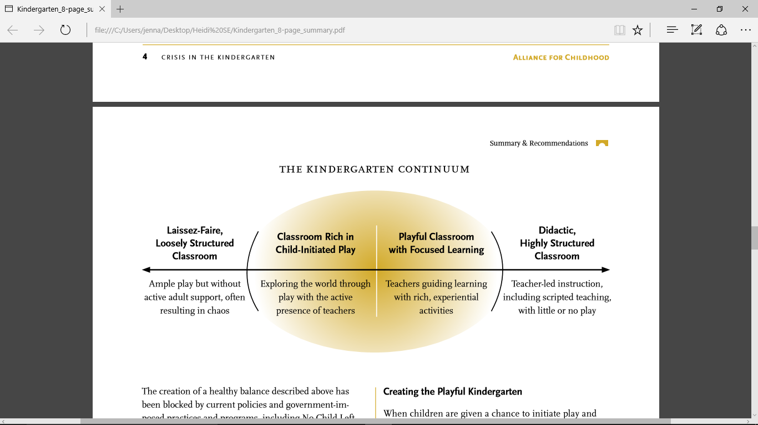
Teaching in the Sweet Spot
Miller, E., & Almon, J. Summary and recommendations of Crisis in the Kindergarten: Why Children Need to Play in School. A report from the Alliance for Childhood. Retrieved from http://www.allianceforchildhood.org/sites/allianceforchildhood.org/files/file/Kindergarten_8-page_summary.pdf

