Connecting the Story of Drama


intent:
Participants practice reading and applying information from the vignettes and the interactions and strategies in the Preschool Curriculum Framework.

OUTCOME:
Participants reflect on and connect the reading to the personal teaching style they utilize when using drama to bring stories to life.

Materials Required:

- Preschool Curriculum Framework (PCF), Vol. 2, pp. 88-89
- Preschool Learning Foundations (PLF), Vol. 2, p. 15

Time: 20 minutes
Process:
PArt 1 (Understanding Foundations)
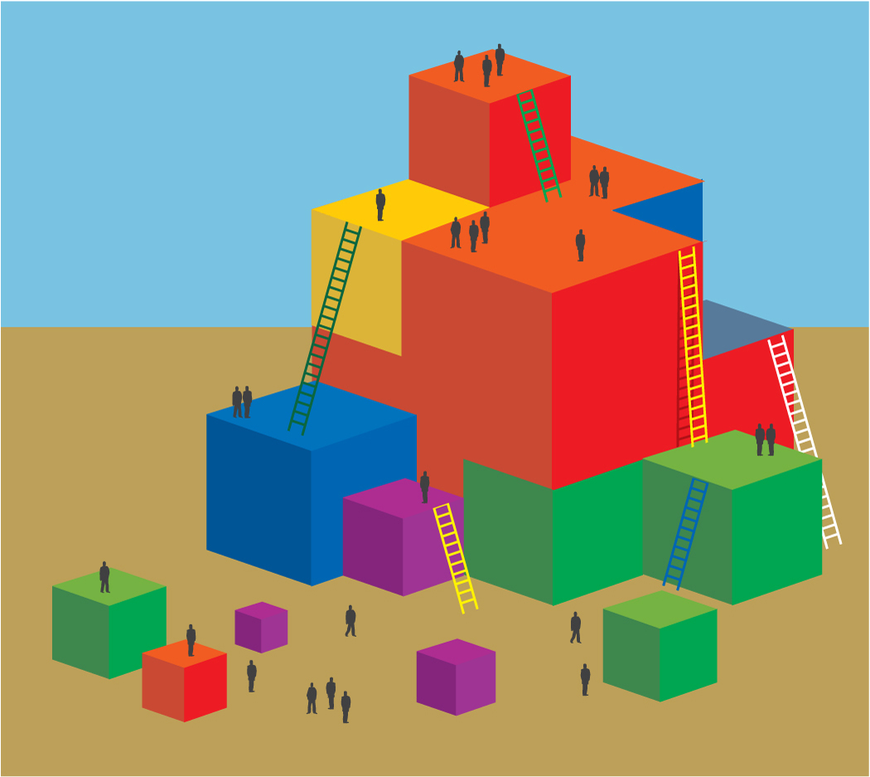
- Ask participants to identify the first foundation in the Drama substrand, Notice, Respond, and Engage (PLF, Vol. 2, p. 15).
- The key to this foundation is drama vocabulary. Using a photocopy or pencil, underline each vocabulary word in the examples.
- Noting the sections underlined, participants compare the differences between the foundations examples at 48 and 60 months.
- Table groups discuss the following questions:
  - What do you notice?
  - How is this different from what you might do for a child approaching the 60 months’ foundation?
  - What other domains might this scaffolding support?

PART 2 (UNDERSTANDING APPLICATIONS)
- Locate The Three Billy Goats Gruff vignette and teachable moment in the PCF, Vol. 2, p. 88.
- Table groups read the vignette and then discuss the following questions:
    - What was your immediate impression of the vignette?
    - What part of the vignette have you seen or have you done something similar in your classroom?
    - What part of the vignette would you want to replicate?
    - What did you discover that might work for facilitating drama foundation 1.1?
SHARE OUT OPTIONS:
- Ask participants to turn to their elbow partner and share one thing they are going to take away from this activity.
- Ask participants to take 10 seconds per tablemate and share one take-away (use a chime to indicate 10 seconds).

