Integrated Partner Visual Art


intent:
Gain hands-on experience with visual art.

OUTCOME:
Participants experience visual art in an integrated manner.

Materials Required:

- Paint
- Huge box
- Marbles
- Ping pong balls
- Other items that roll
- Paper to fit in the box

Time: 5 minutes

Process:
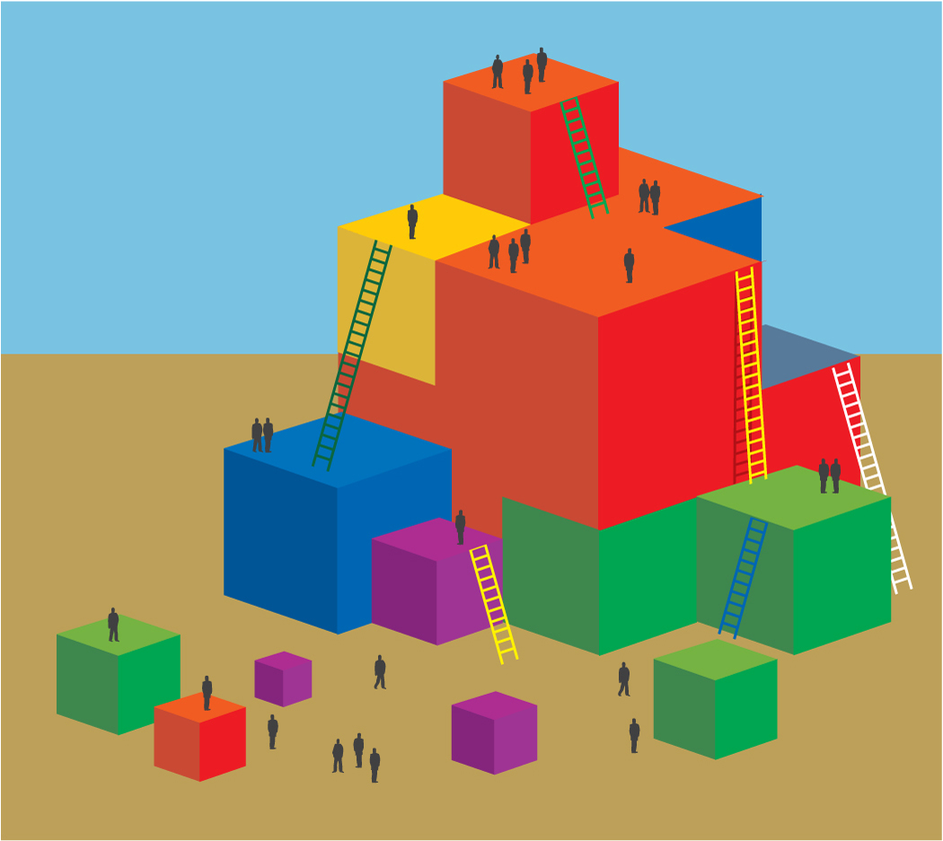
- Share materials that are available for partners to creat art together including boxes, paper, marbles, paints etc.
- Invite participants to find a partner and gather materials to create together.
- After participants experience creating partner art invite them to discuss the domains they experienced.
- For support they can look at the sample domains art relates to on the slide.

