Using the Masters to Enhance the Joy of Art



intent:
Use influences from the masters of art to support the development of visual art foundations in an activity.

OUTCOME:
Experience three different forms of visual art and apply practice toward the facilitation of the visual art foundation.

Materials Required:

- Handout 8: Masters of Art
- Preschool Learning Foundations (PLF), Volume 2
- Preschool Curriculum Framework (PCF), Volume 2

Time: 15 minutes

Process:
Part 1:
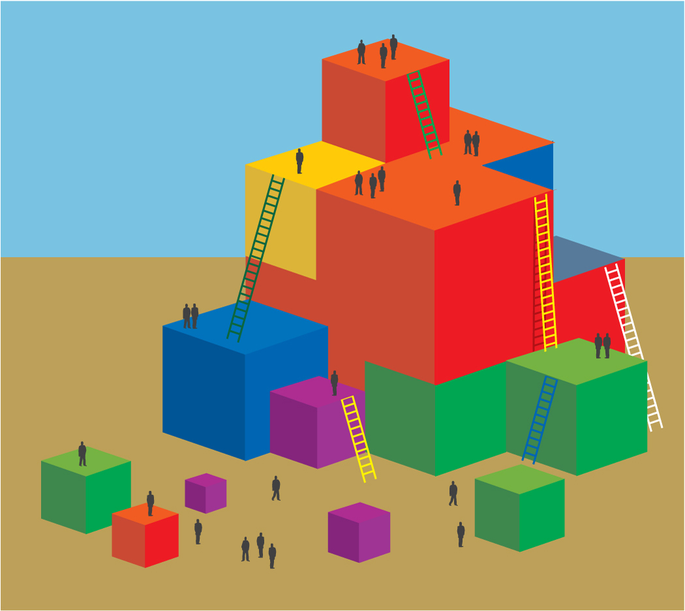
Participants:
- Find their activity group.
- Follow the instructions to experience a new art activity inspired by their art master.
- Discuss and answer the reflection questions on the chart paper.

Part 2:
Participants return to seats and share experiences with tablemates using the following questions:
  - What was joyful about this experience to you? Why was it joyful? How might you recreate this joy for children?
  - How you might change the experience to be more developmentally appropriate?
  - Why might this experience specifically benefit a child with a disability in your program?
  - Which substrand of the visual art foundation does this experience specifically enhance?
  - What materials would you need on hand to make this opportunity available to children?
Remember to jot down ideas on your painter’s pallet action plan.

