Environment and Materials


intent: Explore the environments and materials that support creative learning and learning through creative experiences.

OUTCOMES: Participants interact as they review lists of materials that can be used to support creative learning and learning through creative experiences. They also create a “to-do list” of materials to add to their classroom environment.

Materials Required:

- Table tent cards with one strand name on each card
- Handout 1: Visual and Performing Arts Materials Action Plan
- Appendix A of the Visual and Performing Arts chapter

Time: 20 minutes
Process:
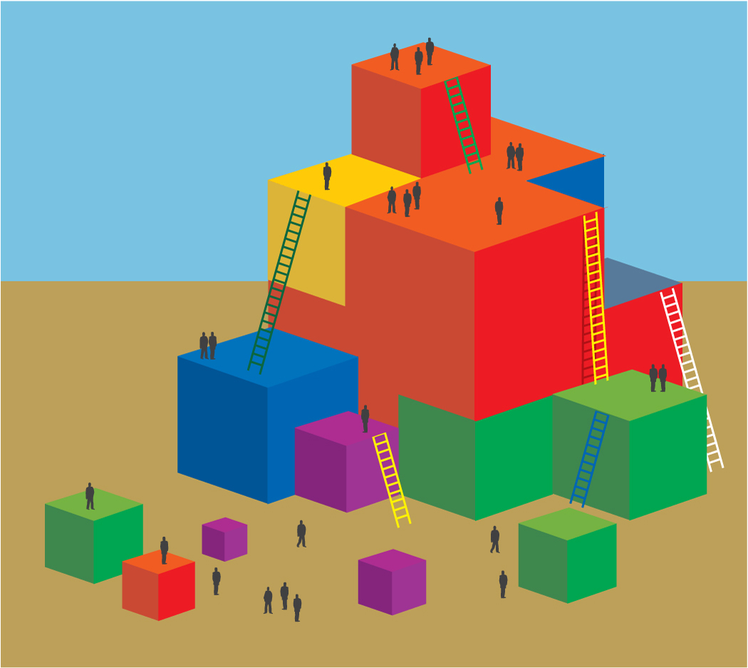
- Participants read the section of appendix A that corresponds to the strand on their table tent.
- Together, they highlight all of the materials that anyone at the table is currently or has used in the classroom.
- Each individual should note on Handout 2: Visual and Performing Arts Materials Action Plan one or more new items to add to the classroom in the following week.

OPTION:
See option two on Activity 3B: Environment and Materials.

