Environment and Materials

intent: Explore the environments and materials that support creative learning and learning through creative experiences.

OUTCOMES: Participants interact with materials that can be used to support creative learning and learning through creative experiences. They also create a “to-do list” of materials to add to their classroom environment.


Materials Required:
- Table tent cards with one strand name on each card
- Boxes of materials for each strand (Make enough boxes so that each table can work with one box. For ideas on materials, see appendix A.)
- Handout 1: Visual and Performing Arts Materials Action Plan

Time: 20 minutes

Process:
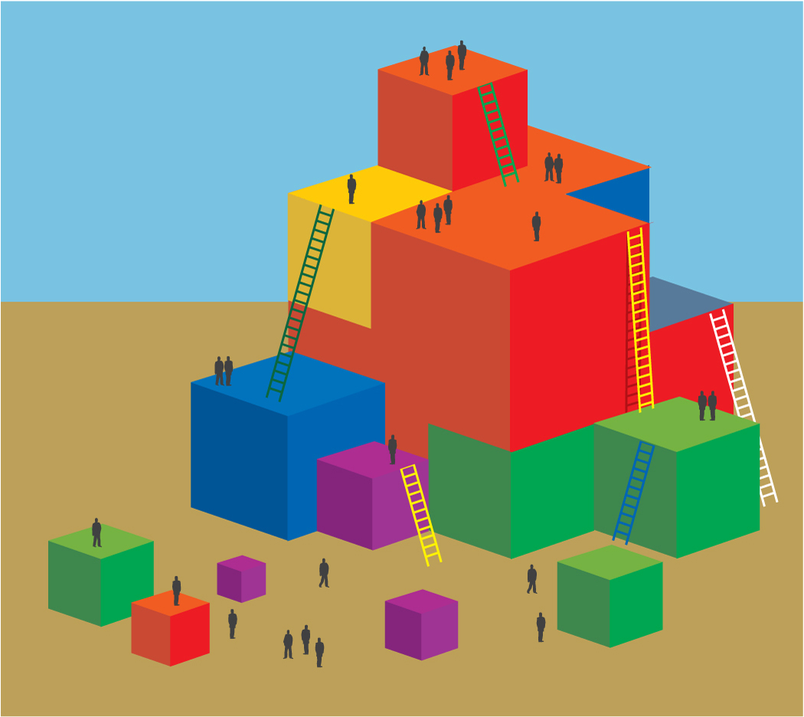
- Each table sends one member to get the box of materials that matches the strand on their table tent.
- Participants spend 10 minutes using and experiencing the materials individually and with others at the table.
- As they work, participants discuss the “processing questions” on the slide.
- Each individual should note on Handout 1: Visual and Performing Arts Materials Action Plan one or more new items to add to the classroom in the following week.

OPTIONS:
The presenter can:
- Each table to discuss these questions.
- Ask each question verbally and have the table discuss as a group one question at a time.
- Ask each question verbally and have a few people share out on their experience.
- Ask for a silent 30 seconds to process each question. Presenter reads the question, says, “Thinking time for 30 seconds,” and then provides 30 seconds to share thoughts with a neighbor.

