Visual Arts Invitations through the Environment


intent: Consider how to infuse visual arts opportunities throughout the entire classroom environment.

OUTCOME: Participants explore ways to infuse opportunities for children to develop skills and knowledge in visual arts throughout all areas in the classroom environment.

Materials Required:
- Handout 5: Suggested Visual Arts Materials (optional)
- Handout 6: Visual Arts Invitations through the Environment worksheet (one copy for each participant)
- Preschool Curriculum Framework, Volume 2

Time: 20-40 minutes
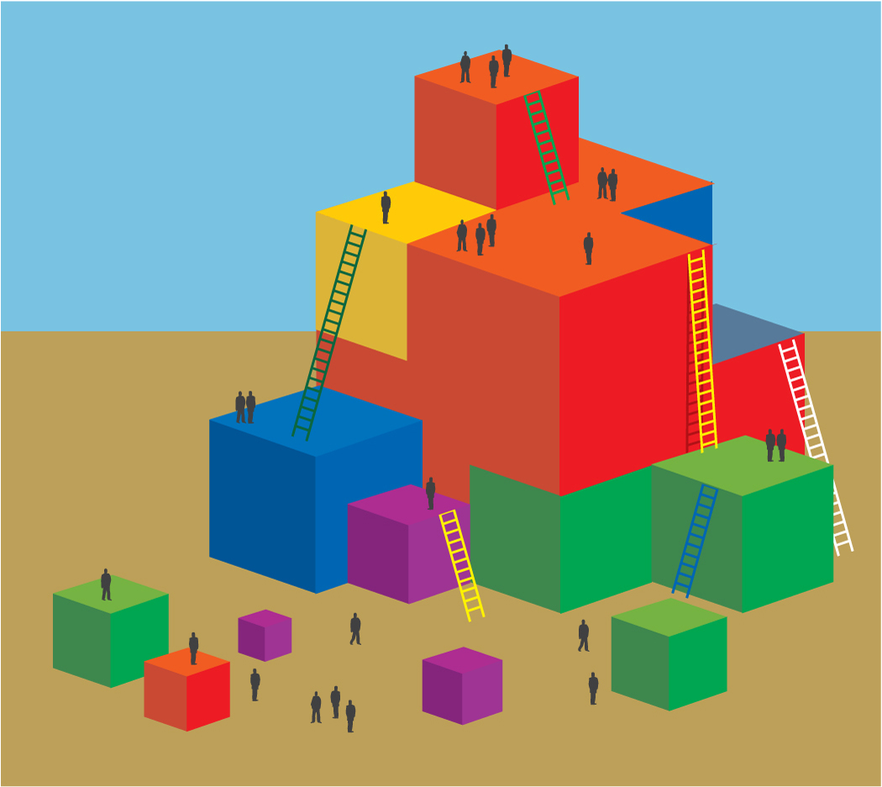
Process:
- Give each participant a copy of Handout 6: Visual Arts Invitations through the Environment worksheet.
- Ask each table team to jot down ideas to infuse visual art opportunities through the classroom environment. Direct participants to pages 54-56 in the Preschool Curriculum Framework, Volume 2, to stimulate thinking.
- Model the activity by saying something like, “Let’s look for an example from the interactions and strategies. Can someone read, help children acquire painting skills through practice with the tools. What area of the environment might this take place? What other ideas do you have for integrating art around the classroom and outside?”
- Solicit one or two responses from the group and say, “Remember, visual arts include things like drawing, painting, chalk, sculpting, collage work, and making three dimensional art works. Think of opportunities to view visual art, build visual art skills, and create visual art.”
- Give participants 20 minutes to jot down ideas.
- Then ask each group share out five best ideas. Ask each participant to write down one idea they would like to try on the action plan. (If no action plan provided, just ask them to create one.)

OPTIONS:
- Ask each group to choose one area on which to focus.
- Participants split up the areas within their table group. Each participant uses the Preschool Curriculum Framework, Volume 2, to fill in ideas they would use to enhance their assigned area. After 10 minutes, table participants share out ideas. End with each person at the table verbally committing to try one new thing.
.

