Opportunities for Music Development throughout the Daily Routines


intent: Consider how to infuse music opportunities throughout the entire daily routine.

OUTCOME: Participants explore ways to infuse opportunities for children to develop skills and knowledge in music throughout all parts of the program day.


Materials Required:
- Handout 5: Suggested Visual Arts Materials (optional)
- Handout 7: Opportunities for Music Development throughout the Daily Routine (one copy for each participant)
- Preschool Curriculum Framework, Volume 2

Time: 20-40 minutes
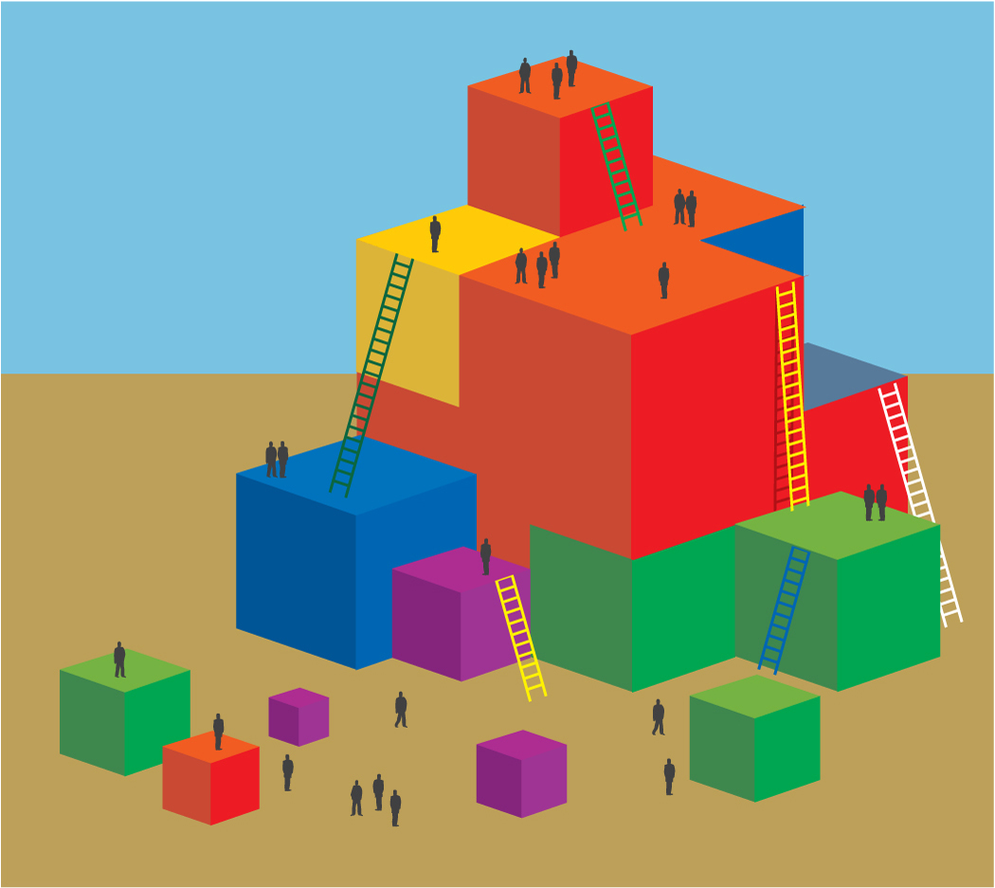
Process:
- Give each participant Handout 7: Opportunities for Music Development throughout the Daily Routine worksheet.
- Ask each table group to jot down ideas to infuse music opportunities throughout the day. Direct them to Interactions and Strategies, page 65, in the Preschool Curriculum Framework, Volume 2 to stimulate thinking.
- Model the activity by saying, “Let’s look for an example at outdoor time. Page 65 talks about making instruments for outdoor musical play. So we might think of adding a box of cans and containers to the outdoor environment and inviting children to make drums for an outdoor parade. What other ideas do you have for children to participate in visual arts outside?” Solicit responses from the group and remind them, “Music includes things like listening to music, singing, keeping a beat, playing musical instruments, making sound effects, moving to music, and drawing pictures to music. Think of opportunities to listen to, build skills, and create music.”
- Give participants 20 minutes to jot down their ideas.
- Then ask each group to share out their five best ideas. Ask each participant to write down one idea they would like to try on the action plan. (If no action plan is provided, ask them to create one.)
OPTIONS:
- Have participants divide the times on the daily schedule within the table group.
- Have participants split up times of day within the table group. Then use the framework to fill in ideas to add music opportunities to that time of day. After 10 minutes, table participants share out ideas. End with each person at the table verbally committing to try one new thing.

